HEALTHY PACKED LUNCHES
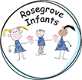
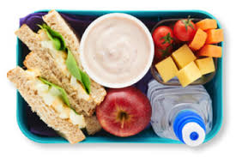
We encourage all our children to eat healthily and we follow healthy schools’ advice from other agencies, who support us.

Packed Lunches should ideally contain a sandwich (or substitute), fruit, low fat yoghurt and a non-fizzy drink.

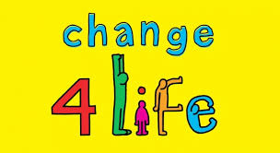

Useful guidance can be found on the NHS Change 4 Life Healthier Lunchboxes link:
https://www.nhs.uk/change4life/recipes/healthier-lunchboxes

We know that some children will often prefer to eat sweet things at lunchtime, but we continue to ask that you DO NOT send your child with:
chocolate bars, sweets or fizzy drinks.
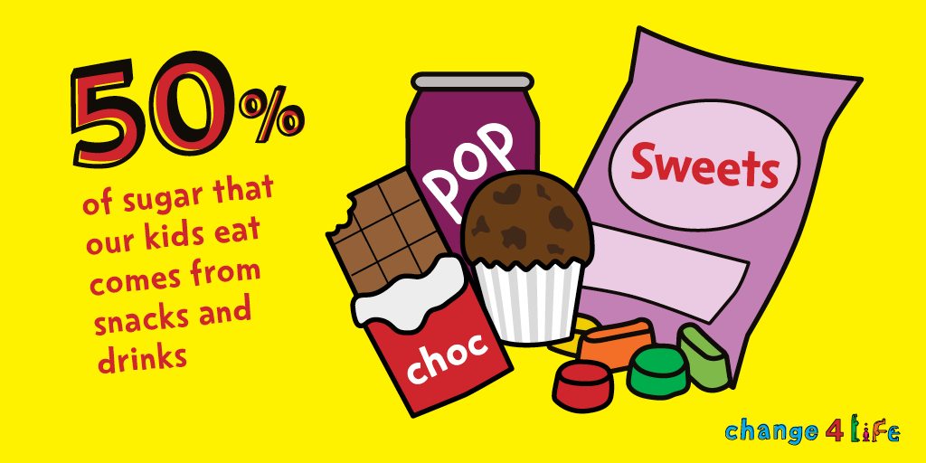
If children have a lot of sweet things in their packed lunch, we will help them to make the right choices about what to eat.
*We recently sent some information out to families regarding the healthy and balanced school lunches that infant children are entitled to, FREE OF CHARGE. These are a great option for young children*.

