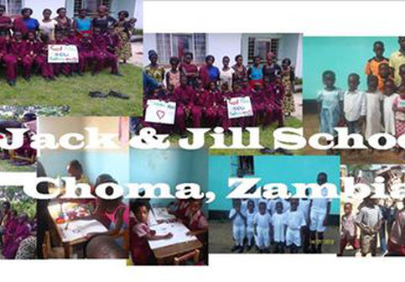
18.7.2016 Thank you!
With your help we have raised £800 already toward the cost of building a library for the children of the Jack and Jill school in Zambia.
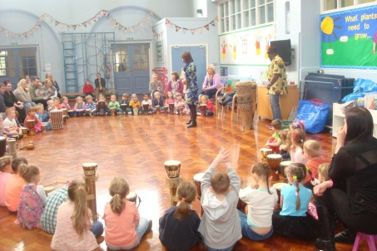
Phil and Frank who support the charity, have been in school recently to talk to the Year 2 children about what it is like to live in Zambia and go to school there. It was really lovely to see Phil talking to the children again, as it was this group that started our links with school when they were in Reception!

REception Rainbow Day 2014
Can we have your Old school jumpers?!
On their visit they explained that the children who attend the Jack and Jill school need warm jumpers that they can wear at night and asked if we had any old school jumpers that we could donate. As the Year 2 children are leaving, they thought that they might donate their old Rosegrove jumpers to Jack and Jill.
We will collect any old jumpers and ensure that they are given to Phil and Frank before their next visit to Zambia in December.

