

Schools must use the funding to make additional and sustainable improvements to the quality of PE and sport they offer. This means that you should use the Primary PE and Sport Premium to:

- develop or add to the PE and sport activities that your school already offers
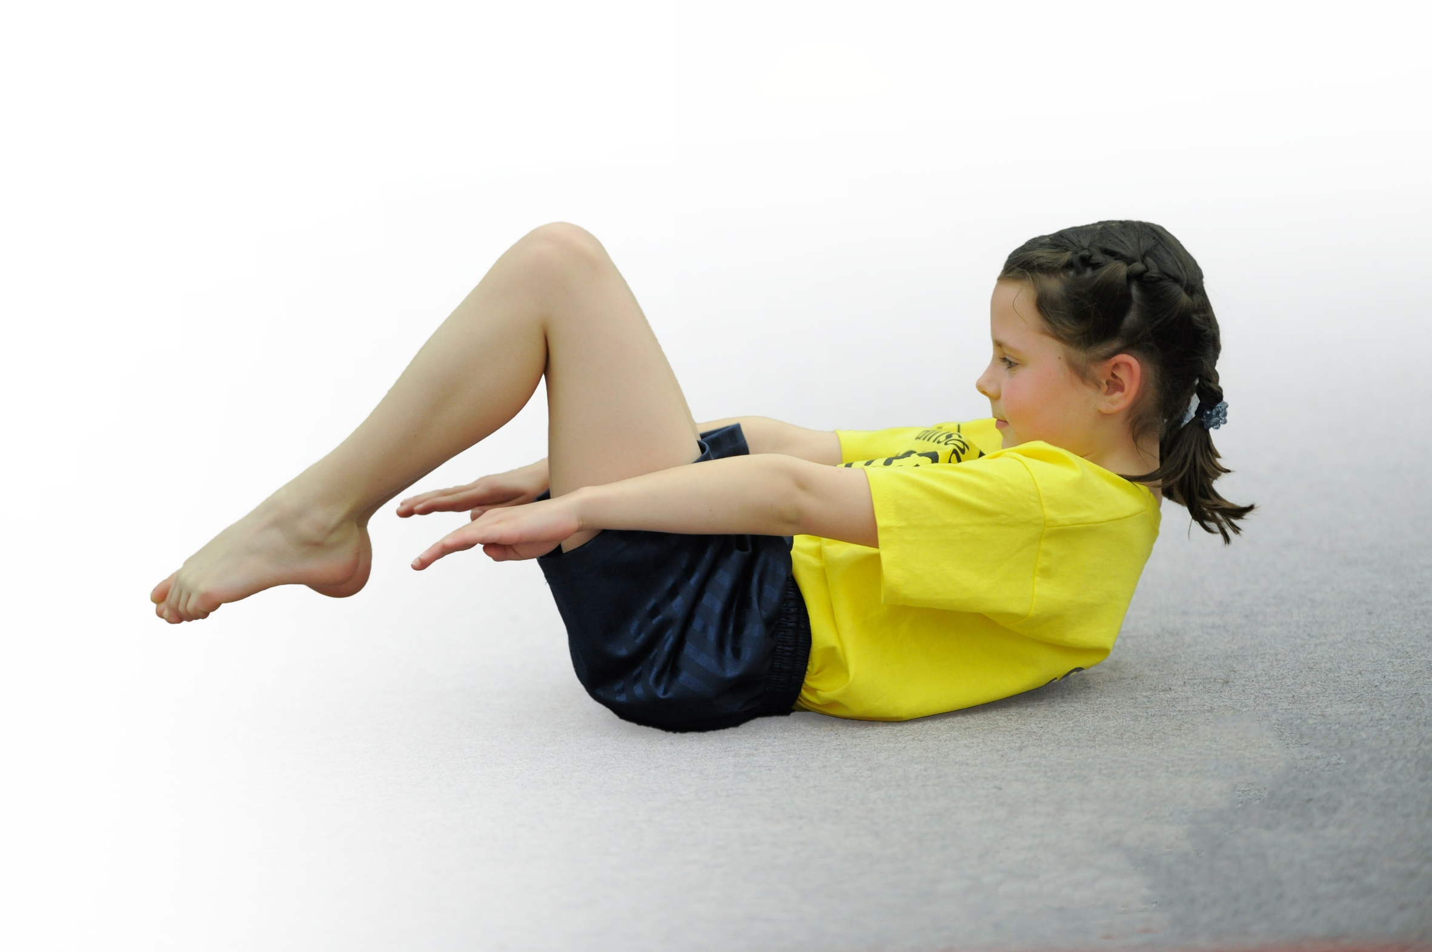
- build capacity and capability within the school to ensure that improvements made now will benefit pupils joining the school in future years

Please visit gov.uk for the revised DfE guidance including the 5 key indicators across which schools should demonstrate an improvement. This document will help you to review your provision and to report your spend. DfE encourages schools to use this template as an effective way of meeting the reporting requirements of the Primary PE and Sport Premium.

We recommend you start by reflecting on the impact of current provision and reviewing the previous spend.
Under the Ofsted Schools Inspection Framework, inspectors will assess how effectively leaders use
the Primary PE and Sport Premium and measure its impact on outcomes for pupils, and how effectively governors hold them to account
for this.

Schools are required to publish details of how they spend this funding as well as on the impact it has on pupils’ PE
and sport participation and attainment.
We recommend regularly updating the table and
publishing it on your website as evidence
of your ongoing review into how you are using the money
to secure maximum, sustainable impact. To see an example of how to complete the table please click HERE.

Support for review and reflection - considering the 5 key indicators from DfE, what development needs are a priority for your setting and your students now and why? Use the space below to reflect on previous spend, identify current need and priorities for the future.

Key achievements to date: | Areas for further improvement and baseline evidence of need:  Key Priorities
-All children have had access to outside agency coaches who deliver curriculum FMS skills sessions weekly.  -Opportunities for all children to access a range of extra-curricular activities including after school, breakfast clubs and structured lunchtime play.  -Active Math’s used weekly to ensure cross curricular links. All teachers incorporate the scheme into their weekly planning. Children have additional opportunities to be active accessing ‘The Grove’ outdoor learning area.  -Subject Leader has completed a subject overview which includes lesson observations, pupil interviews, peer teaching and data collection/analysis. This has increased staff confidence and the HQ delivery of PE. Subject lead now has the confidence to lead the subject as a whole with improvements being made consistently.  -Children have accessed OAA activities which were previously unavailable. Helping the children to broaden the range of experiences they can access.  -All children accessing weekly Level 1 Intra competition within the curriculum. All Level 2 Inter school events accessed through the SSP.  -Through the SSP children have accessed 46 hours of HQ coaching in a range of sports including: Cycling, Netball, Dance, Rounders, Cricket, Rugby and Multiskills. | -Look to extend and improve the current playground facilities with a focus on climbing and risk taking elements.  -Look to enhance the playground markings to create different physical activity zones on the playground to enhance structure and physicality of playtimes.  -Ensure that all children are achieving age related expectations in Fundamental Movement Skills. Provide the opportunity to all children to achieve a level of ‘maturity’ in as many skills as they can.  -Staff to take more of an active role in the delivery of FMS. Staff to teach alongside the outside coaches rather than taking an observational role.  -Offer more OAA opportunities for all children across school. Broaden the children’s experiences of outdoor learning.  Continue to offer weekly Level 1 competitive opportunities within the curriculum. Ensure all children can access whole school events.  Attempt to incorporate my personal best initiative throughout school.

Meeting national curriculum requirements for swimming and water safety | Please complete all of the below*:
What percentage of your current Year 6 cohort swim competently, confidently and proficiently over a distance of at least 25 metres? | %
What percentage of your current Year 6 cohort use a range of strokes effectively [for example, front crawl, backstroke and breaststroke]? | %
What percentage of your current Year 6 cohort perform safe self-rescue in different water-based situations? | %
Schools can choose to use the Primary PE and Sport Premium to provide additional provision for swimming but this must be for activity over and above the national curriculum requirements. Have you used it in this way? | Yes/No
*Schools may wish to provide this information in April, just before the publication deadline.

Action Plan and Budget Tracking
Capture your intended annual spend against the below 6 key indicators. Clarify the success criteria and evidence of impact that you intend to measure to evaluate for students today and for the future.

Academic Year: 2018/19 | Total fund allocated: £ 17,080  (current projected spend £ 17,258.61) | Date Updated:25/06/19
Key indicator 1: The engagement of all pupils in regular physical activity – Chief Medical Officer guidelines recommend that primary school children undertake at least 30 minutes of physical activity a day in school |  |  |  | Percentage of total allocation:
 |  |  |  | 44%
School focus with clarity on intended impact on pupils: | Actions to achieve: | Funding allocated: | Evidence and impact: | Sustainability and suggested next steps:
-Look to extend and improve the current playground facilities with a focus on more focused physical activity.  -Look to enhance the playground markings to create different physical activity zones on the playground to enhance structure and physicality of playtimes.  -Look to make enhancements to the gates to allow more outdoor activity. | Continue to implement active elements to lessons with a focus on keeping the children engaged through physical activity  -Continue to use ‘The Grove’ outdoor area regularly to encourage outdoor/active learning  -Revamp of the whole playground area including climbing/play equipment, markings to zone off areas of the playground and fixed games equipment.  -Make enhancements to security measures including the gates for the playground. | £7448.61  Breakdown of cost:  £4061 for markings  £1632.61 for traverse/climbing wall  £1755 for gate enhancements | Playground markings have created zoned areas which have applied more structure to playtimes and dinner times. This has subsequently improved behavior, reduced accidents and substantially improved the amount of physical activity carried out.  Based on a weekly survey on average around 30 children are accessing and using our new running lanes in a safe but competitive manner and around  20 children are using our new soft surface part of the playground where gymnastic activities are carried out.  Over 80 percent of children in each class has been rated as green in relation to how confident they are when using the trim trail equipment and climbing wall.  All children in year 1 have consistently accessed ‘The Grove area for outdoor learning and the area was used by all children in school during ‘Den Day’.  Funda educator continues to deliver structured playtime activities and reinforces correct use of markings.  Improvements to gates have allowed children to access playground more. | Continue to model and assess the use of the trim trail equipment in relation to its correct use and the confidence of the different users in each year group and class.  Monitor impact of different zones on the playground and constantly reinforce how they are to be used.  Provide children with varying equipment to use on the playground to allow them to  further promote their fundamental movement skills.  To ensure we provide children with more opportunities to carry out learning both on the playground and in the grove area to promote outdoor learning and opportunities for cross curricular learning.  Funda educator to continue to provide activities outside during lunch times.  Security measures constantly analyzed to provide layers of security for the playground.
Key indicator 2: The profile of PE and sport being raised across the school as a tool for whole school improvement |  |  |  | Percentage of total allocation:
 |  |  |  | 38%
School focus with clarity on intended impact on pupils: | Actions to achieve: | Funding allocated: | Evidence and impact: | Sustainability and suggested next steps:
-Ensure that all children are achieving age related expectations in Fundamental Movement Skills. Provide the opportunity to all children to achieve a level of ‘maturity’ in as many skills as they can. | Employ outside agency for 1 day per week to deliver a range of activities. Physical Activities in Breakfast Club, Whole school ‘Wake & Shake including staff and parents, Lunchtime activities, 4 curriculum lessons and extracurricular clubs. | £6460 | -Funda have delivered their own scheme in relation to the fundamental movement skills. They have delivered sessions all year to both year 1 and year 2.  They have delivered a football breakfast club for gifted and talented footballers and 12-14 children have attended each week. They have delivered 6 afterschool clubs consisting of multi skills, cricket, dodgeball, netball, football and athletics and 15-20 have attended.  Baseline Assessments and End of Key Stage 1 Assessments  Catch: I-23, D-33, M-0  Catch: I-5, D-32, M-22  Run: I-20, D-35, M-0  Run: I-4, D-35, M-19  Hop: I-24, D-33, M-0  Hop: I-4, D-35, M-22  Skip: I-24, D-32, M-1  Skip:I-2, D-27, M-29  Jump: I-22, D-35, M-1  Jump: I-2, D-29, M-27  Throw Over: I-31, D-26, M-0  Throw Over: I-2, D-38, M-17  Throw Under: I-24, D-33, M-0  Throw Under: I-3, D-30, M-25  Rolling a Ball: I-10, D-46, M-0  Rolling a Ball: I-3, D-37, M-18  Bouncing a Ball: I-31, D-26, M-0  Bouncing a Ball: I-4, D-41, M-13  Kicking a Ball: I-33, D-23, M-1  Kicking a Ball: I-3, D-39, M-16 | Funda to continue to provide all the listed items and continue to make amendments, analyze and improve their scheme of work.  Funda to continue to provide a gifted and talented breakfast club for the able footballers in school.  Funda to continue to provide a variation of afterschool clubs for a variety of children to access.  Funda to continue to assess children on their fundamental movement skills and aim to attain good progress.

Key indicator 3: Increased confidence, knowledge and skills of all staff in teaching PE and sport |  |  |  |  | Percentage of total allocation:
 |  |  |  |  | %
School focus with clarity on intended  impact on pupils: | Actions to achieve: |  | Funding  allocated: | Evidence and impact: | Sustainability and suggested  next steps:
-Staff to take more of an active role in the delivery of FMS. Staff to teach alongside the outside coaches rather than taking an observational role. | Perform regular monitoring by Subject Leader in the following areas:  -Analysis of Data  -Learning Walks and observations during Funda sessions, coaching sessions and Teacher led teaching.  -Peer Teaching  -Pupil Voice  -Half Termly Assessments |  | CPD Courses (SSP Buy In)  See Funda Costs above | Both year 1 and year 2 teachers all get involved during Funda sessions where possible and give support to children who are struggling.  Subject leader observations have taken place and feedback has been provided to all staff.  Funda educator observed reception teaching Funda scheme of work on movement skills and discussed with subject leader.  Subject leader attended upskilling sessions for both year 1 and 2 on the fundamental movement skills.  Subject leader observed Funda educator and facilitated in the teaching and delivery for the majority of the year. | Staff continue to be involved in delivery of PE with Funda Educator.  Subject leader to continue to complete half termly monitoring of different areas of PE including observations, anaylsis of data, pupil interviews, peer teaching and learning walks.  For all teachers to become very confident in the assessment of fundamental movement skills.  To continue to have discussions regarding Educator assessments and teacher assessments to attain accurate judgements.
Key indicator 4: Broader experience of a range of sports and activities offered to all pupils |  |  |  |  | Percentage of total allocation:
 |  |  |  |  | %
School focus with clarity on intended  impact on pupils: |  | Actions to achieve: | Funding  allocated: | Evidence and impact: | Sustainability and suggested  next steps:
Offer more OAA opportunities for all children across school. Broaden the children’s experiences of outdoor learning. |  | Create a link with Lowerhouse to establish premises/grounds to undertake a range of outdoor learning experiences.  -Accessing the SSP coaching program | None | Playground has been used more along with the Grove for outdoor activities.  Meetings have been held and links have been established with Lowerhouse in relation to using their grounds and agreements have been made. | To use grounds/facilities Lowerhouse have to offer for outdoor activities  To look at other establishments or ways of providing our children with a wide variety of experiences.
Key indicator 5: Increased participation in competitive sport |  |  |  |  | Percentage of total allocation:
 |  |  |  |  | %
School focus with clarity on intended  impact on pupils: |  | Actions to achieve: | Funding  allocated: | Evidence and impact: | Sustainability and suggested  next steps:
Continue to offer weekly Level 1 competitive opportunities within the curriculum. Ensure all children can access whole school events.  Attempt to incorporate my personal best initiative throughout school. |  | -Providing whole school competitive sports events.  -Access all available SSP events and enter ‘B’ teams where possible.  Introduce competitive activities/challenges to playground to encourage use of new markings. |  | Whole school sports day carried out on local area along with linked Nursery. Feedback gathered from children in each class who all stated they loved the day and had lots of fun.  Cluster comps have provided 32+ children in year 2 with opportunities to compete in different sporting activities such as football, dodgeball, T-ball and athletics. | Continue to access all SSP competitions available for our school.  To implement independent activity cards for the children to carry out on the playground.  To always send ‘B’ teams where possible to cluster competitions to allow more children to access them.
Key indicator 6: Improved collaboration and growth of local networks including local partners and external agencies |  |  |  |  | Percentage of total allocation:
 |  |  |  |  | 20%
School focus with clarity on intended  impact on pupils: |  | Actions to achieve: | Funding  allocated: | Evidence and impact: | Sustainability and suggested  next steps:
Buy into local SSP to ensure continuity and growth of local infra-structure. Universal offer for pupils and coordinated support package |  | This Provides:  -Over 120 inter competitions and festivals.  -SSCO support from a specialist PE teacher who will work alongside and support the school.  -CPD Courses  -Play Leader, Young Ambassador and C4L champion training  -Gifted and talented provision.  -School Sports Coaching Programme (35hrs)  -Cycling Training Programmes  -Network Support for PE Leads and Head Teachers  -YST membership with a link to a national network | £3350 | All year 2 children have accessed 5 sessions of cricket, 6 sessions of Rugby, 4 sessions of tennis and 10 children from year 2 accessed 4 sessions of skills 2 play.  All year 1 children have accessed 4 sessions of dance with Sanderson’s, 5 sessions of football and 5 sessions of rounders with coaches from Burnley Leisure.  Subject leader gained advise and support from numerous meetings with SSCO and numerous emails.  Accessed a variety of sporting competitions through SSP.  All reception children accessed and completed TOTS on tyres program and from feedback from reception class teachers, children progressed really well. | Continue to access everything the SSP has to offer in relation to all the activities and the extensive support they provide.  Continue with TOTS on tyres program and look at also accessing the learn to ride program.

