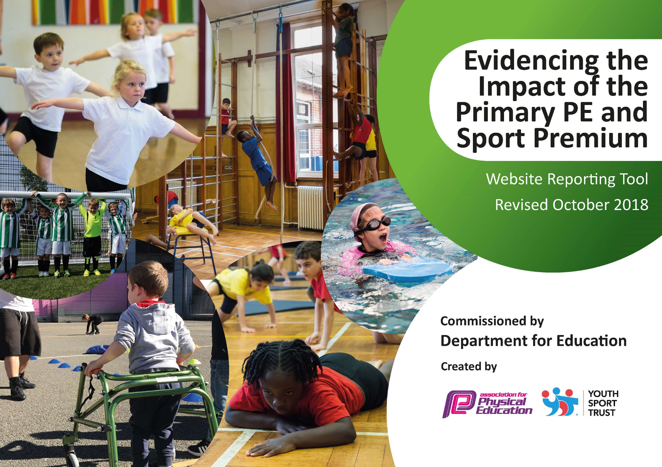
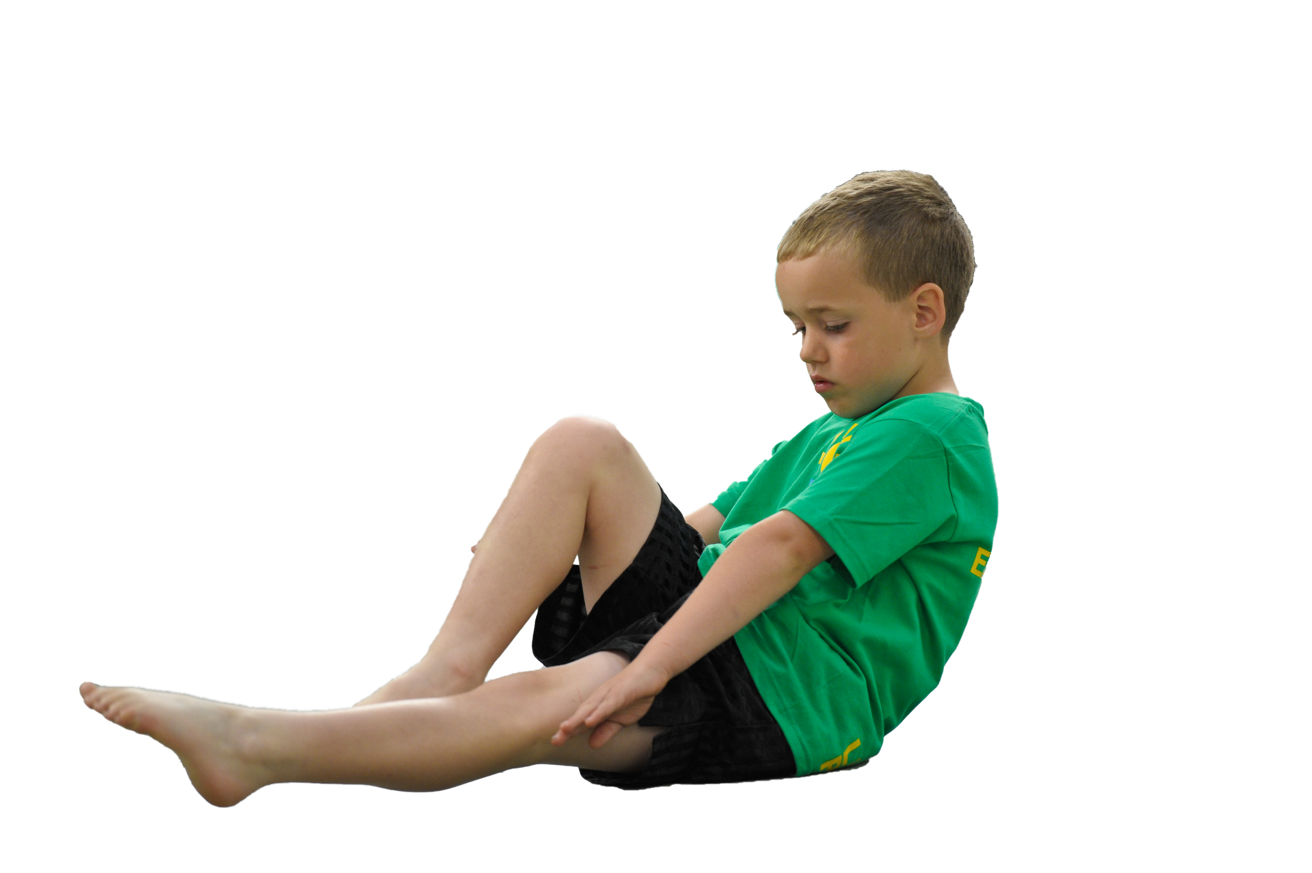
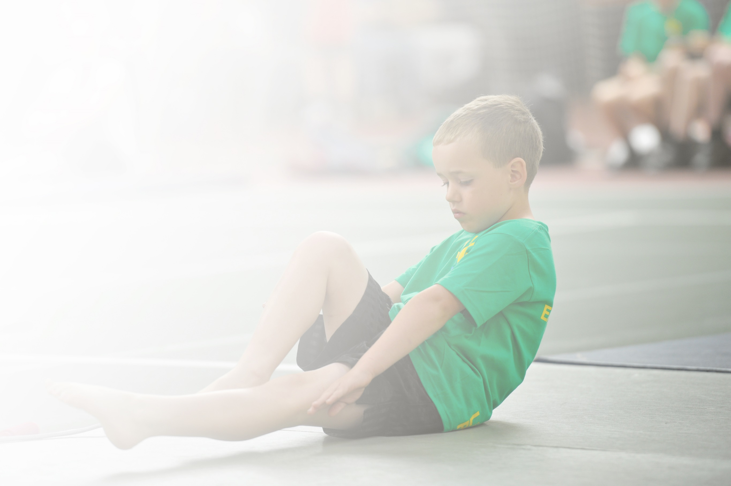
Schools must use the funding to make additional and sustainable improvements to the quality of Physical Education, Sport and Physical Activity (PESPA) they offer. This means that you should use the Primary PE and Sport Premium to:

- Develop or add to the PESPA activities that your school already offer
- Build capacity and capability within the school to ensure that improvements made now will benefit pupils joining the school in future years

Please visit gov.uk for the revised DfE guidance including the 5 key indicators across which schools should demonstrate an improvement. This document will help you to review your provision and to report
your spend. DfE encourages schools to use this template as an effective way of meeting the reporting requirements of the Primary PE and Sport Premium.

We recommend you start by reflecting on the impact of current provision and reviewing the previous
spend. Under the Ofsted Schools Inspection Framework, inspectors will assess how effectively leaders use the Primary PE and Sport Premium and measure its impact on outcomes for pupils, and how effectively governors hold them to account for this.

Schools are required to publish details of how they spend this funding as well as on the impact it has on pupils’ PE and sport participation and attainment by the end of the summer term or by 31 July 2019 at the
latest.
We recommend regularly updating the table and publishing it
on your website throughout the year, as evidence of your
ongoing review into how you are using the money to
secure maximum, sustainable impact. To see an
example of how to complete the table please
click HERE.

Support for review and reflection - considering the 5 key indicators from DfE, what development needs are a priority for your setting and your students now and why? Use the space below to reflect on previous spend, identify current need and priorities for the future.

Key achievements to date: | Areas for further improvement and baseline evidence of need:
-New playground markings installed raising the level of physical activity at break times. Also created a safer environment for active play with designated zones for different activities.  -More children accessing outdoor learning area on a daily basis increasing further activity.  -Outside Coaching Company (Funda) delivering weekly curriculum sessions based on FUNdamental skills. Noticeable improvement in children’s ability to perform FMS.  -Regular monitoring process of subject now in place with subject leader conducting observations, learning walks, pupil interviews and staff questionnaires.  -Continue to work closely alongside the SSP, accessing all programs and offers available including CPD, competitions and coaching program.  -Increased knowledge of staff in the understanding, assessment and delivery of FMS.  -80% of children now at a green level of confidence to be able to use trim trail and climbing equipment safely and effectively.  -Relationship with local school to share grounds/facilities for more opportunities to access outdoor activities. | -Funda to Continue – Focus on upskilling EYFS staff as well as preparing children for baseline assessments at the beginning of year 1.  -SSP to continue and continue to utilise the full package of what is offered including CPD support and opportunities for physical activity.  -Extend trim trail by including climbing apparatus (monkey bars). To ensure that the children are utilising all the playground equipment as a tool for enhancing their physical activity and promoting a healthy lifestyle.  -Physical activity of 30 mins to be attained from increased structure of playground activities including enhanced equipment and resources, zoned areas and personal best cards.  -Targeted populations? SEN, PP, FSM,- C4L curriculum/extra-curricular  -Teacher CPD to be continued to be enhanced.  -Healthy mind/mindfulness and promoting a healthy balanced lifestyle.  -School games values – integrate into physical activity sessions.

Meeting national curriculum requirements for swimming and water safety | Please complete all of the below:
What percentage of your current Year 6 cohort swim competently, confidently and proficiently over a distance of at least 25 metres?  N.B. Even though your children may swim in another year please report on their attainment on leaving  primary school. | %
What percentage of your current Year 6 cohort use a range of strokes effectively [for example, front crawl, backstroke and breaststroke]? | %
What percentage of your current Year 6 cohort perform safe self-rescue in different water-based situations? | %
Schools can choose to use the Primary PE and Sport Premium to provide additional provision for swimming but this must be for activity over and above the national curriculum requirements. Have you used it in this way? | Yes/No

Action Plan and Budget Tracking
Capture your intended annual spend against the 5 key indicators. Clarify the success criteria and evidence of impact that you intend to measure to evaluate for students today and for the future.

Academic Year: 2019/20 | Total fund allocated: £17,080  Total projected spend £17,060 | Date Updated:26.05.20
Key indicator 1: The engagement of all pupils in regular physical activity – Chief Medical Officer guidelines recommend that primary school children undertake at least 30 minutes of physical activity a day in school |  |  |  | Percentage of total allocation:
 |  |  |  | 44%
Intention | Implementation |  | Impact
School focus with clarity on intended impact on pupils: | Actions to achieve: | Funding allocated: | Evidence and impact: | Sustainability and suggested next steps:
-Look to extend and improve the current playground facilities with a focus on more focused physical activity.  -Look to enhance the playground markings to create different physical activity zones on the playground to enhance structure and physicality of playtimes.  -Look to make enhancements to the gates to allow more outdoor activity. | Continue to implement active elements to lessons with a focus on keeping the children engaged through physical activity  -Continue to use ‘The Grove’ outdoor area regularly to encourage outdoor/active learning  -Revamp of the whole playground area including climbing/play equipment, markings to zone off areas of the playground and fixed games equipment.  -Make enhancements to security measures including the gates for the playground. | £4061 for markings  £1632.61 for traverse/climbing wall  £1755 for gate enhancements | Playground markings have created zoned areas which have applied more structure to playtimes and dinner times. This has subsequently improved behaviour, reduced accidents and substantially improved the amount of physical activity carried out.  Based on a weekly survey on average around 30 children are accessing and using our new running lanes in a safe but competitive manner and around  20 children are using our new soft surface part of the playground where gymnastic activities are carried out.  Over 80 percent of children in each class has been rated as green in relation to how confident they are when using the trim trail equipment and climbing wall.  All children in year 1 have consistently accessed ‘The Grove area for outdoor learning and the area was used by all children in school during ‘Den Day’.  Funda educator continues to deliver structured playtime activities and reinforces correct use of markings.  Improvements to gates have allowed children to access playground more. | Continue to model and assess the use of the trim trail equipment in relation to its correct use and the confidence of the different users in each year group and class.  Monitor impact of different zones on the playground and constantly reinforce how they are to be used.  Provide children with varying equipment to use on the playground to allow them to  further promote their fundamental movement skills.  To ensure we provide children with more opportunities to carry out learning both on the playground and in the grove area to promote outdoor learning and opportunities for cross curricular learning.  Funda educator to continue to provide activities outside during lunch times.  Security measures constantly analyzed to provide layers of security for the playground.
Key indicator 2: The profile of PESSPA being raised across the school as a tool for whole school improvement |  |  |  | Percentage of total allocation:
 |  |  |  | 37%
Intention | Implementation |  | Impact
School focus with clarity on intended impact on pupils: | Actions to achieve: | Funding allocated: | Evidence and impact: | Sustainability and suggested next steps:
Ensure that all children are achieving age related expectations in Fundamental Movement Skills. Provide the opportunity to all children to achieve a level of ‘maturity’ in as many skills as they can.  To provide the children with opportunities to implement the skills they have learned in sporting situations and contexts. | Employ outside agency for 1 day per week to deliver a range of activities. Physical Activities in Breakfast Club, Whole school ‘Wake & Shake including staff and parents, Lunchtime activities, 4 curriculum lessons and extracurricular clubs.  Funda educator and class teachers to work with the children on Fundamental movement skills in the PE lessons and to work to attain progress in each skill from the children. Year 2 Class teacher to assess the children on each skill at the end of ks1.  COVID 19 – Funda delivered their scheme of work up until the end of Spring 1. Funda will be continuing to work alongside our staff in the next academic year | For Funda  £6460 | Funda have delivered their own scheme in relation to the fundamental movement skills. They have delivered sessions all year to both year 1 and Reception.  They have delivered a football breakfast club for gifted and talented footballers and 12-14 children have attended each week. They have delivered 6 afterschool clubs consisting of multi skills, cricket, dodgeball, netball, football and athletics and 15-20 have attended.  Baseline Assessments and End of Key Stage 1 Assessments  Catch: I-23, D-33, M-0  Catch: I-5, D-32, M-22  Run: I-20, D-35, M-0  Run: I-4, D-35, M-19  Hop: I-24, D-33, M-0  Hop: I-4, D-35, M-22  Skip: I-24, D-32, M-1  Skip:I-2, D-27, M-29  Jump: I-22, D-35, M-1  Jump: I-2, D-29, M-27  Throw Over: I-31, D-26, M-0  Throw Over: I-2, D-38, M-17  Throw Under: I-24, D-33, M-0  Throw Under: I-3, D-30, M-25  Rolling a Ball: I-10, D-46, M-0  Bouncing a Ball: I-31, D-26, M-0  Bouncing a Ball: I-4, D-41, M-13  Kicking a Ball: I-33, D-23, M-1  COVID 19 – Some of the Year 2 assessments were unable to be finalized and therefore data is not shown on this document. | All members of staff to deliver the Funda scheme of work and constantly make improvements and adaptations to suit their class.  All members of staff to speak to PE coordinator for any advice or questions to do with the Funda scheme of work.  PE coordinator to take over the delivery of breakfast club and afterschool activity clubs.  Class teachers to be confident with the assessment of the fundamental movement skills.

Key indicator 3: Increased confidence, knowledge and skills of all staff in teaching PE and sport |  |  |  | Percentage of total allocation:
 |  |  |  | 0%
Intention | Implementation |  | Impact
School focus with clarity on intended  impact on pupils: | Actions to achieve: | Funding  allocated: | Evidence and impact: | Sustainability and suggested  next steps:
Year 2 staff to take over the delivery of the Funda scheme of work to enhance their knowledge of the content of the scheme on how best to implement it.  Reception staff to observe and take a role in delivery of the fundamental movement skills by Funda educator.  Year 1 to take a more active role in the delivery of Fundamental movement skills by Funda educator.  Main intention is to ensure all staff are confident to take over the delivery of the Funda scheme of work and become familiar with the content. | Perform regular monitoring by Subject Leader in the following areas:  -Analysis of Data  -Learning Walks and observations during Funda sessions, coaching sessions and Teacher led teaching.  -Peer Teaching  -Pupil Voice  -Assessments  Year 2 teachers to continuously work on improving the Funda scheme of work and adapt it to suit our school and ultimately the children in our school.  COVID 19 – All monitoring activities completed up until the end of Spring 2. |  | Year 2 teachers are now fully emerged in teaching the Funda scheme of work to their own classes. They are following the scheme like the educator would and making ongoing changes to suit the learners in their class.  Teacher questionnaires have been completed on confidence of delivery of the Fundamental Movement skills with over 90% of the responses being rated as green (rated using traffic light system).  Subject leader observations have taken place in which it was highlighted that not only were the teachers confident but the children were engaged also. Feedback has been provided to all staff.  Subject leader observed Funda educator delivering Reception and Year 1 scheme of work to see how staff should be delivering it.  Enhanced confidence in delivery of Funda scheme of work has enabled children to be challenged further on each individual skill. The children have immensely benefited from the teacher delivering the Funda scheme of work in relation to their progress and they have also contributed their own ideas on how to add variations to the different activities. | All members of staff to deliver the Funda scheme of work and constantly make improvements and adaptations to suit their class.  All members of staff to speak to PE coordinator for any advice or questions to do with the Funda scheme of work.  PE coordinator to take over the delivery of breakfast club and afterschool activity clubs.  Class teachers to be confident with the assessment of the fundamental movement skills.
Key indicator 4: Broader experience of a range of sports and activities offered to all pupils |  |  |  | Percentage of total allocation:
 |  |  |  | 2%
Intention | Implementation |  | Impact
School focus with clarity on intended  impact on pupils: | Actions to achieve: | Funding  allocated: | Evidence and impact: | Sustainability and suggested  next steps:
Offer more OAA opportunities for all children across school. Broaden the children’s experiences of outdoor learning by increasing the use of the ‘Grove area’ as an outdoor classroom.  Offer children a chance to take part in some of the different Funda afterschool clubs that have become available for implementation.  Children continue to be exposed to the range of activities being offered by Burnley Leisure and and SSP including: rugby, cricket, gymnastics, tennis, netball, football, dodgeball, handball, athletics, rounders, skills 2 play and tots on tyres. | Take part in outdoor orienteering activity at Thompson park.  Continue to access all of the different range of activities offered within the SSP.  The grove area has now been fitted with a heater and so is to be used as an outdoor classroom throughout the whole year. Year 1 are to use the grove area for groups to take part in physical cross curricular activities every day.  Provide the children with an opportunity to take part in some of the different activities offered by Funda.  Covid 19 – Orienteering activity didn’t happen and had to be postponed due to the virus and will be completed when it is safe to do so. | £300 | Playground has been used more along with the Grove for outdoor activities.  Outdoor activity day to take place at Thompson park in which all 58 year 2 children will attend.  Activities offered by Funda have been increased and subsequently activities children have taken part in are different from those in the previous year.  The Grove area was used as an outdoor classroom during the full first term to cater for those children who learn best practically. On average 12 year 1 children accessed outdoor cross curricular learning each day. | Continue to provide children with opportunities for outdoor activities in a range of different local facilities.  Take part in outdoor orienteering day at Thompson park.  Continue to use grove area and playground for outdoor activities.
Key indicator 5: Increased participation in competitive sport |  |  |  | Percentage of total allocation:
 |  |  |  | 0%
Intention | Implementation |  | Impact
School focus with clarity on intended  impact on pupils: | Actions to achieve: | Funding  allocated: | Evidence and impact: | Sustainability and suggested  next steps:
Continue to offer weekly Level 1 competitive opportunities within the curriculum. Ensure all children can access whole school events.  To introduce personal best card challenges onto the playground for the children to carry out at playtimes and lunchtimes (play leaders to facilitate activities). | -Providing whole school competitive sports events.  -Access all available SSP events and enter ‘B’ teams where possible.  Introduce competitive activities/challenges to playground to encourage use of new markings.  COVID 19 – Accessed competitions up until the end of Spring 1. |  | Whole school sports day carried out on local area along with linked Nursery. Feedback gathered from children in each class who all stated they loved the day and had lots of fun.  Cluster comps have provided 40+ children in year 2 with opportunities to compete in different sporting activities such as football, dodgeball, T-ball and athletics. | Continue to access all SSP competitions available for our school.  SSP have created new package which encompasses 3 x competitive activity learning mornings/afternoons.  Continue to have a yearly sports day for competition.  Daily mile challenge between each class in school to see who can get the furthest on the map.  To always send ‘B’ teams where possible to cluster competitions to allow more children to access them.  To continue to use activity card (personal best) on the playground to promote personal competitive physical activity.
Key Indicator 6: Improved collaboration and growth of local networks including local partners and external agencies |  |  |  | Percentage of total allocation
 |  |  |  | 20%
Intention | Implementation |  | Impact
School focus with clarity on intended  impact on pupils: | Actions to achieve: | Funding  allocated: | Evidence and impact: | Sustainability and suggested  next steps:
Buy into local SSP to ensure continuity and growth of local infra-structure.  To collaborate with nursery in relation to holding a shared sports day in which some of the nursery children are involved. | This Provides:  -Over 120 inter competitions and festivals.  -SSCO support from a specialist PE teacher who will work alongside and support the school.  -CPD Courses  -Play Leader, Young Ambassador and C4L champion training  -Gifted and talented provision.  -School Sports Coaching Programme (35hrs)  -Cycling Training Programmes  -Network Support for PE Leads and Head Teachers  -YST membership with a link to a national network  To create a sports day that allows the nursery children to take part but also have an element of competition.  COVID 19 – Accessed SSP until the end of Spring 1.Sports day postponed until safe to carry out. | For SSP  £3350 | All year 2 children have accessed 4 sessions of cricket, 4 sessions of gymnastics, 4 sessions of netball 6 sessions of Rugby, 4 sessions of tennis and 10 children from year 2 accessed 4 sessions of skills 2 play.  All year 1 children have accessed 4 sessions of dance with Sanderson’s.  Subject leader gained advise and support from numerous meetings with SSCO and numerous emails.  Accessed a variety of sporting competitions through SSP.  All reception children accessed and completed TOTS on tyres program and from feedback from reception class teachers, children progressed really well. | Continue to access everything the SSP has to offer in relation to all the activities and the extensive support they provide.  Continue with TOTS on tyres program.

