Reception Home Learning – Summer 2
Phonics
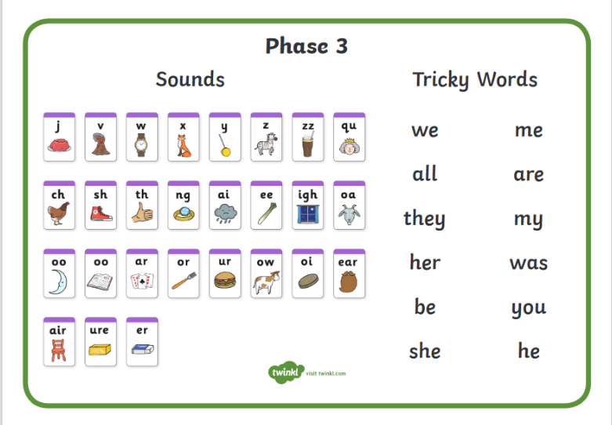
This half term we are continuing to learn our phase 3 sounds and tricky words:

Mathematics
Communication, Language and Literacy
Physical Development
Topic

- Play games such as tricky word hunt, musical statues, musical bumps, snap, bingo etc.
- Sort the sounds into bowls based on the sounds in them.
- Find the sounds in books.
- Read sentences with the phase 3 sounds in – can you colour the digraphs (two letters making one sound) or the trigraphs (three letters making one sound).
- Practise spelling words like: cow, coin, beard, chair, pure, boxer
- Practise reading words like: owl, card, turn, chain, night, fair, fur.
- Practise reading captions / sentences:
They need to see an owl at night.
Sam sat on the red chair.
I will go to the fair with my Mum.
- Practise writing simple captions and sentences:
- Can you write the sounds and tricky words cursively?
Remember:
Tricky words: Those words that cannot be sounded out.
Reading strategy: point to and say all the sounds in the word, repeat. Blend the sounds together.
Spelling strategy: say the word, say all the sounds you can hear in the word, write them down, check your word by reading it.
Phase 4
We will be learning to read phase 4 words and tricky words. Can you practise reading and writing these words:
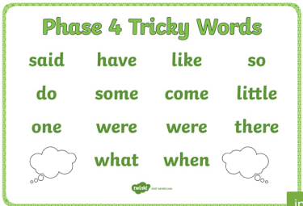

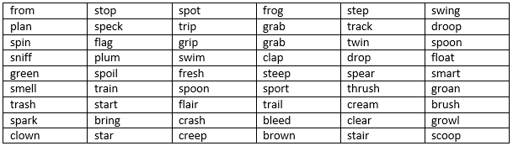
Maths
- Count on and back to and from 30.
- Make a set of 0-20 number cards, can you put them in order? Can you do it faster?
- Can you order a set of random numbers.
- Use a mirror to show doubling (adding the same number to itself) i.e. 1 + 1 = 2.
- Can you gather some objects and share them out equally between two soft toys or two family members (Halving).
- Can you use marks to work out addition and subtraction number sentences.
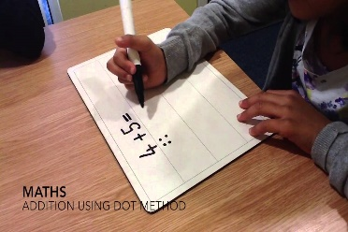
- Can you solve some problems i.e. Sam has two teddies, Ifran has 6 cars, how many toys altogether? Ben went to the shop with 10p, he spent 5p. How much does he have left?
- Can you make your own number line – say one more or one less than a given number.
- Write numbers 10-20. Remember to check they are the right way around.
- Say the months of the year in order. Can you draw a picture to represent each month?
- Can you identify 3d shapes around your house and describe them.
- Make some symmetrical patterns. Symmetrical means the same on both sides.
Communication, Language and Literacy
- Read a story or ebook – talk about your favourite part, who were the characters? Where was the story set, What happened at different points of the story.
- Draw a story map of your chosen story.
- Read a non-fiction book (information book) or use the internet to find some interesting facts. Can you write some facts? You could make your own information sheet or book.
- Use the picture below to make up some sentences with some interesting words in.
Remember to: use your Kung Fu punctuation – Capital letter, finger space, full stop and check it.
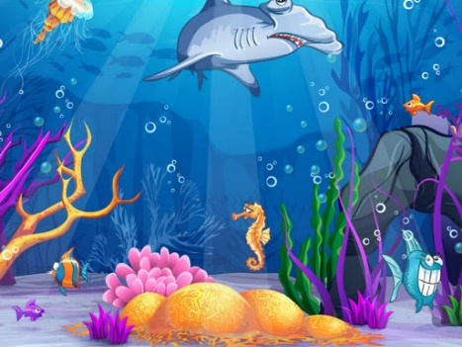

- Access oxford owls to read various books. (Log in sent during learning lockdown).
Physical Development
- Set up an obstacle course in your garden or house using household items i.e. plant pots, cushions etc.
- Make some play dough and do some dough disco like we do in school.
- Bake some biscuits, cakes, flap jacks, fruit salad. Remember to ask an adult to help you.
- Make some bird feeders.
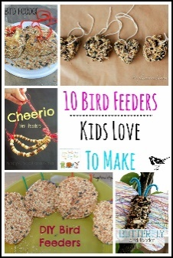

- Can you move in various ways i.e. like a farm animal, slither like a snake, stomp like an elephant etc.
- Practise cutting out animal shapes.
- Practise cutting up patterns.
Topic – Animals
- Make a list of animals and sort into categories – where they live? What they eat? Do they fly or not? How many legs etc?
- Watch videos or research your favourite animal.
- Make and write an information sheet on your favourite animal.
- Sort animals and their young, what are the adult ones and called and baby ones called?
- Draw, paint, colour or collage an animal – remember to include lots of detail.
- Can you make an enclosure using household objects or a camouflage area for an animal?
- Describe an animal to your grown up, can they guess what it is? You could guess your grown-ups.
- Plan a trip to the jungle, arctic, under the sea. What will you take? What will you need? What will you see? What will you hear? What could you touch? Where will you sleep?
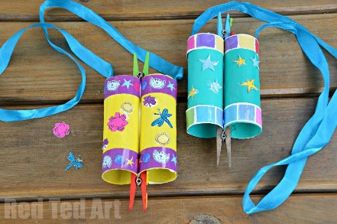
- Make some binoculars so you can look at the animals in your local environment.

