
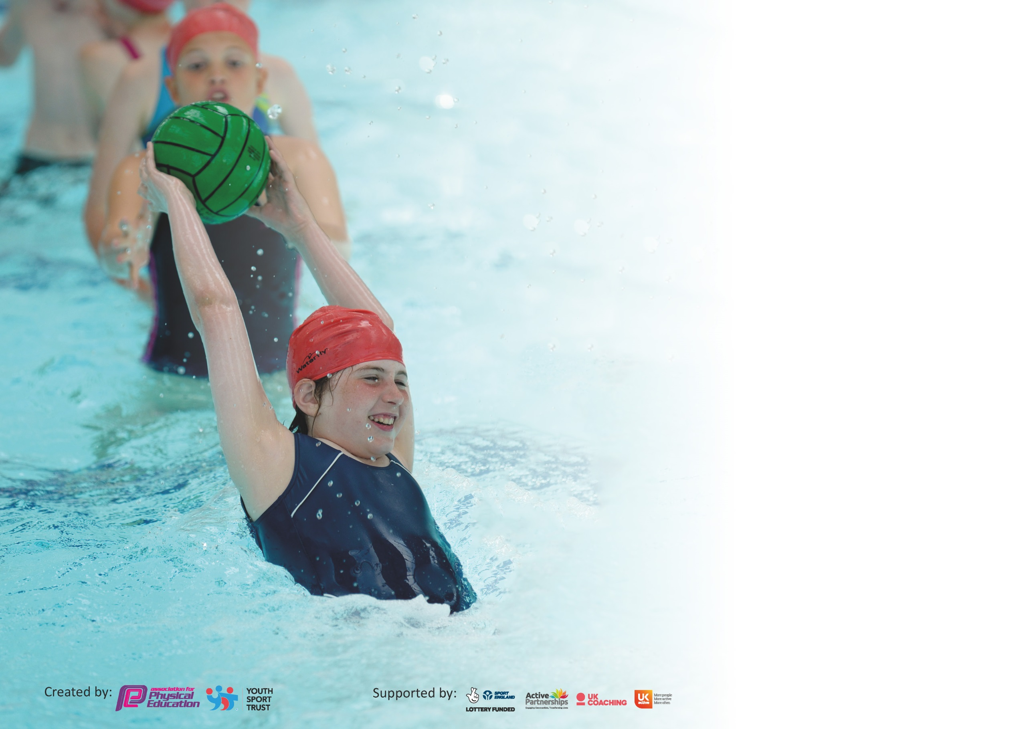

It is important that your grant is used effectively and based on school need. The Education Inspection Framework (Ofsted 2019 p64) makes clear there will be a focus on ‘whether leaders and those responsible for governors all understand their respective roles and perform these in a way that enhances the effectiveness of the school’.

Under the Quality of Education criteria (p41) inspectors consider the extent to which schools can articulate their curriculum (INTENT), construct their curriculum (IMPLEMENTATION) and demonstrate the outcomes which result (IMPACT).

To assist schools with common transferable language this template has been developed to utilise the same three headings which should make your plans easily transferable between working documents.

Schools must use the funding to make additional and sustainable improvements to the quality of Physical Education, School Sport and Physical Activity (PESSPA) they offer. This means that you should
use the Primary PE and Sport Premium to:

- Develop or add to the PESSPA activities that your school already offer
- Build capacity and capability within the school to ensure that improvements made now will benefit pupils joining the school in future years

Please visit gov.uk for the revised DfE guidance including the 5 key indicators across which schools should demonstrate an improvement. This document will help you to review your provision and to report your spend. DfE encourages schools to use this template as an effective way of meeting the reporting requirements of the Primary PE and Sport Premium.

We recommend you start by reflecting on the impact of current provision and reviewing the previous spend.

Schools are required to publish details of how they spend this funding as well as on the impact it has on pupils’ PE and sport participation and attainment by the end of the summer term or by 31st July 2020 at the latest.

We recommend regularly updating the table and publishing it on your website throughout the year. This evidences your ongoing self-evaluation of how you are using the funding to secure maximum, sustainable impact. Final copy must be posted on your website by the end of the academic year and no later than the 31st July 2020. To see an example of how to complete the table please click HERE.

Support for review and reflection - considering the 5 key indicators from DfE, what development needs are a priority for your setting and your pupils now and why? Use the space below to reflect on previous spend and key achievements and areas for development.

Key achievements to date until July 2023: | Areas for further improvement and baseline evidence of need:
-All Staff have now become confident in the use and delivery of the Funda scheme of work and are confident in assessing the different fundamental movement skills.  -Continued to utilised SSP and utilised the full package of what is offered including CPD support and opportunities for physical activity.  -Playground markings continue to aid the level of physical activity taking place during playtimes and the zones are encouraging children to access different movements and activities.  -More children accessing outdoor learning area daily increasing further activity.  -Teacher CPD continued to be enhanced.  -Healthy mind/mindfulness and promoting a healthy balanced lifestyle.  -School games values – integrated into physical activity sessions. | -To successfully combine the Funda Scheme of work with the Lancashire scheme of work to ensure a well-rounded coverage of skills and activities are sustained.  -SSP to continue and continue to utilise the full package of what is offered including CPD support and opportunities for physical activity.  -Extend trim trail by including climbing apparatus (monkey bars). To ensure that the children are utilising all the playground equipment as a tool for enhancing their physical activity and promoting a healthy lifestyle.  - Update and further extend playground markings to further facilitate physical activities at playtimes and lunchtimes.  -Physical activity of 30 mins to be attained from increased structure of playground activities including enhanced equipment and resources, markings and zoned areas.  -Provide opportunities for afterschool clubs to take place for all children and to target lower 20% of learners.

Meeting national curriculum requirements for swimming and water safety.
What percentage of your current Year 6 cohort swim competently, confidently and proficiently over a distance of at least 25 metres?  N.B. Even though your pupils may swim in another year please report on their attainment on leaving  primary school at the end of the summer term 2020. | %
What percentage of your current Year 6 cohort use a range of strokes effectively [for example, front crawl, backstroke and breaststroke]? | %
What percentage of your current Year 6 cohort perform safe self-rescue in different water-based situations? | %
Schools can choose to use the Primary PE and Sport Premium to provide additional provision for swimming but this must be for activity over and above the national curriculum requirements. Have you used it in this way? | Yes/No

Action Plan and Budget Tracking
Capture your intended annual spend against the 5 key indicators. Clarify the success criteria and evidence of impact that you intend to measure to evaluate for pupils today and for the future.

Academic Year: 2021/22 | Total fund allocated: £26,740  £17,740 plus £9000 underspend from last year | Date Updated: 19.06.23
Key indicator 1: The engagement of all pupils in regular physical activity – Chief Medical Officer guidelines recommend that primary school pupils undertake at least 30 minutes of physical activity a day in school |  |  |  | Percentage of total allocation:
 |  |  |  | %
Intent | Implementation |  | Impact
Your school focus should be clear what you want the pupils to know and be able to do and about  what they need to learn and to  consolidate through practice: | Make sure your actions to achieve are linked to your intentions: | Funding allocated: | Evidence of impact: what do pupils now know and what can they now do? What has changed?: | Sustainability and suggested next steps:
-To make enhancements to the outdoor provision area at the back of school so it can be used as a designated active learning area for learners in school alongside ‘The Grove’.  -Continue to use the playground markings and zones to encourage structured physical activity on the playground.  -To continuously enhance the school playground equipment to increase the opportunities for physical activity. | To provide more opportunities to carry out physical activities linked to other areas of learning (cross curricular) in a new area of school.  Ensure that all the trim trail and equipment is being used effectively by all the children.  Monitor the use of the different zoned off areas to ensure that the areas are serving their purpose and being used to enhance physical activity.  Order and implement more varied playground resources to be used in the equipment area and establish a routine for how they are to be stored and more importantly how they are to be used (link equipment use to the fundamental movement skills). | £6119 on resurfacing of back of school to create outdoor learning area.  £12,677 on trim trail refurb, playground markings, decked area and new play structure.  £464 on new playground equipment | Area at the back of school has now been updated and is used daily for both physical activity and supports cross curricular learning (mainly supporting lower 20% children to carry out active maths)  Playground has now been fully zoned off now and all the children in the school are carrying out physical activity within each zone at Lunchtimes.  Playground now has areas to support all the children’s interests across school including gymnastics area, football area, equipment area, reading decking and shaded area, role play area and the trim trail. | Monitor impact of different zones on the playground and constantly reinforce how they are to be used.  Ensure children are carrying out physical activities within the zones.  Continue to provide children with varying equipment to use on the playground to allow them to further promote their fundamental movement skills.  To ensure we provide children with more opportunities to carry out learning in the different areas around school.
Key indicator 2: The profile of PESSPA being raised across the school as a tool for whole school improvement |  |  |  | Percentage of total allocation:
 |  |  |  | %
Intent | Implementation |  | Impact
Your school focus should be clear what you want the pupils to know and be able to do and about  what they need to learn and to  consolidate through practice: | Make sure your actions to achieve are linked to your intentions: | Funding allocated: | Evidence of impact: what do pupils now know and what can they now do? What has changed?: | Sustainability and suggested next steps:
To have final term of Funda support in school and prepare staff for own delivery of scheme in next academic year.  To provide opportunities for all children to practice and progress their fundamental movement skills and ultimately achieve age related expectations in Fundamental Movement Skills.  To provide the children with opportunities to implement the skills they have learned in sporting situations and contexts. | Funda educator worked very closely with class teacher to carry out final year 2 assessments and to finalise curriculum content for next academic year.  Use and adapt the Funda scheme of work to provide children with engaging ways to progress their fundamental movement skills.  KS1 to have 2 lessons a week to practice the fundamental skills and also a session to apply their skills in sporting contexts. | £1710 for final payment of Funda. | Funda have delivered their own scheme in relation to the fundamental movement skills. They have completed end of year assessments which show a vast number of children moving from immature to developing in each skill and a good number of mature learners.  They have delivered 2 afterschool clubs in Summer Term to 20 children in gymnastics and athletics.  The combination of Funda scheme and Lancashire scheme is providing an effective coverage of the objectives in the national curriculum. | Class teachers to continue delivering engaging PE lessons to enhance FMS skills using both schemes of work.  School staff to continue to build up wealth of knowledge and ideas to implement in lessons.  Class teachers to continue to gain accurate assessments of children for developments and progress in PE across school.  Fundamental movement data to be passed on to next school to inform their curriculum maps for year 3.

Key indicator 3: Increased confidence, knowledge and skills of all staff in teaching PE and sport |  |  |  | Percentage of total allocation:
 |  |  |  | %
Intent | Implementation |  | Impact
Your school focus should be clear | Make sure your actions to | Funding | Evidence of impact: what do | Sustainability and suggested
what you want the pupils to know | achieve are linked to your | allocated: | pupils now know and what | next steps:
and be able to do and about | intentions: |  | can they now do? What has
what they need to learn and to |  |  | changed?:
consolidate through practice:
To again ensure that all staff are aware of the curriculum map for what they need to be delivering each half term.  To ensure staff complete fundamental movement assessments and collect in data for subject leader folder.  To ensure resources are in place for both schemes to be delivered effectively. | Perform regular monitoring by Subject Leader in the following areas:  -Analysis of Data  -Learning Walks and observations during Funda sessions, coaching sessions and Teacher led teaching.  -Peer Teaching  -Pupil Voice  -Assessments | £399 for PE app and scheme of work. | Lancashire scheme of work has been used to supplement our Funda scheme of work.  All staff have delivered engaging lessons and followed activities in the order on the curriculum map. | To continue to support staff with use of both schemes and when carrying out assessments.  To combine both the Funda scheme of work and the Lancashire work to ensure that the FMS are being applied within sporting contexts.
Key indicator 4: Broader experience of a range of sports and activities offered to all pupils |  |  |  | Percentage of total allocation:
 |  |  |  | %
Intent | Implementation |  | Impact
Your school focus should be clear | Make sure your actions to | Funding | Evidence of impact: what do | Sustainability and suggested
what you want the pupils to know | achieve are linked to your | allocated: | pupils now know and what | next steps:
and be able to do and about | intentions: |  | can they now do? What has
what they need to learn and to |  |  | changed?:
consolidate through practice:
To continue to provide the children with afterschool activity clubs which consist of varying and fresh content.  To use the outdoor areas to facilitate different physical activity sessions. Year 1 to continue to use the grove as an outdoor classroom and year 2 to use the back of the school in the outdoor area. | Subject leader to deliver afterschool clubs in different sporting areas aiming to cater for lower 20% of learners and gifted learners.  To promote physical activity in different areas of learning using the outdoor learning areas. |  | 3 afterschool clubs have taken place this year with around 10-15 children attending across key stage 1 each time. Afterschool clubs include:  Multi skills, football and cricket. | To continue with the afterschool clubs and provide a wide repour of activities. Activities led by subject leader.

Key indicator 5: Increased participation in competitive sport |  |  |  | Percentage of total allocation:
 |  |  |  | %
Intent | Implementation |  | Impact
Your school focus should be clear | Make sure your actions to | Funding | Evidence of impact: what do | Sustainability and suggested
what you want the pupils to know | achieve are linked to your | allocated: | pupils now know and what | next steps:
and be able to do and about | intentions: |  | can they now do? What has
what they need to learn and to |  |  | changed?:
consolidate through practice:
Continue to offer weekly Level 1 competitive opportunities within the curriculum.  Ensure all children can access whole school events.  To continue offering challenges on the playground for the children to carry out at playtimes and lunchtimes.  To carry out play leader training through the SSP. | To carry out whole school competitive sports events including sports day and class PE competitive activities.  Continue to use competitive activities/challenges to playground to encourage use of new markings. |  | Whole school competitive sports day carried out.  Play leader training has trained a member of staff and children to facilitate activities at lunchtimes. | To attend all the SSP competitions offered to us as a school.  To again use the personal best challenges on the playground to introduce competitive physical activity at playtimes.  To continue to promote competition during PE lessons with class teachers.
Key indicator 6: Improved Collaboration and growth of local networks |  |  |  | Percentage of total allocation:
 |  |  |  | %
Intent | Implementation |  | Impact
Your school focus should be clear | Make sure your actions to | Funding | Evidence of impact: what do | Sustainability and suggested
what you want the pupils to know | achieve are linked to your | allocated: | pupils now know and what | next steps:
and be able to do and about | intentions: |  | can they now do? What has
what they need to learn and to |  |  | changed?:
consolidate through practice:
All young people to be able to access opportunities that support their wellbeing  All young people to be able to access an events programme that will help them recognise improvement and achieve their personal best  Children to be able to access high quality PE | Buy into Burnley SSP  Use associated buy in programmes such as competition and events programme to support children to take part in meaningful competition  Utilise SSP SSCO’s to continue to upskill school staff where necessary.  Access CPD programmes. | £4000 | 16 year 2 children took part in the Autumn Term competitions  The network has allowed us to share good practice and resources and the termly meetings keep us updated.  Using the resources provided by the SSP has helped to keep children active.  Around 32 year 2 children took part in competitions throughout the year which is more than 50% of the year group. | Continue with SSP for specialised coaching, accessing competitions and CPD opportunities.  To sustain and build on developing the ability within the FMS across school.  To promote opportunities for learners to become enthused by a varying range of competitive, sporting activities.

Signed off by
Head Teacher:
Date:
Subject Leader: | Mr Crossley
Date: | 26.06.23
Governor:
Date:

