
Rosegrove
Out of School Club

September 2023

Thank you for choosing to use our breakfast and/or after school club.

Information:
Fees:
Breakfast sessions: £6.00
After School Sessions £12.50
Full Week (with 12.5% Discount) £78.75

Times:
Breakfast Sessions:
We open at 7.45 a.m.

After School Sessions:
Last pick – up is at 5.30 p.m.
School will be closed after this time.

Repeated lateness may incur additional fees.
Fees should be paid at least on week in advance to the school office where possible.
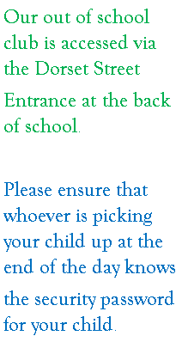
Staff:
Breakfast Club:
Supervisor – Mrs Barlow
Assistant – Mrs Burrows
After School Club:
Supervisors –
Miss Stobbs (mat leave)
Mrs Tee and Mrs Ali
Assistant – Miss Nawaz

