
Rosegrove
Out of School Club

September 2024

Thank you for choosing to use our breakfast and/or after school club.

Information:
From September 2024
Fees:
Breakfast sessions: £6.50
After School Sessions £13
Full Week (with 12.5% Discount) £85

Times:
Breakfast Sessions:
We open at 7.45 a.m.

After School Sessions:
Last pick – up is at 5.30 p.m.
School will be closed after this time.

Repeated lateness may incur additional fees.
Fees should be paid at least one week in advance, to the school office.
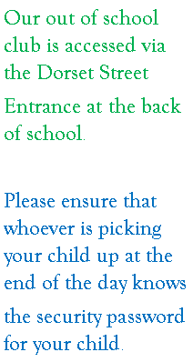
Staff:
Breakfast Club:
Supervisor – Mrs Barlow
Assistant – Mrs Tee
After School Club:
Supervisor – Miss Lupton
Assistant – Mrs Ali

