

Rosegrove Infant School SEND Policy

School Aims

At Rosegrove Infant School all children are valued as individuals and their varying needs are dealt with sensitively and effectively. We believe that each child should receive a broad, balanced and differentiated curriculum ensuring self-esteem and confidence are enhanced and a positive attitude is developed. However, some children will need additional support in order to achieve their true potential and if/where appropriate may benefit from external support. This policy addresses the needs of these children and has been written to support any changes to SEN under SEND legislation and documentation.

The Governing Body and staff of the school will ensure that all pupils have access to a broad and balanced curriculum which meets individual needs. This policy is in keeping with the school’s aims and its policies on teaching and learning, equal opportunities, disability equality and race relations. It is written in accordance with the SEND Code of Practice (2015).

Key Objectives

- Teachers and support staff will provide for the individual needs of pupils by using a range of strategies when the targets or provision set out on their one-page profile or targeted action plan (TAP)
- Parents of pupils with a special educational need will be encouraged to become involved in process from an early stage.
- Training needs of staff will be identified and met as far as possible with regard to:

a. General awareness of and provision for special educational needs.
b. Specific and practical support/training for identified special educational needs and/or
specific difficulties e.g. speech and language.
- Staff and Governors will endeavour to maintain the high level of learning support for children with special educational needs with regard to the funding available.

ROLES AND RESPONSIBILITIES

The Governing Body

The Governing Body with the Head Teacher will determine the school’s general policy and approach to the provision for children with special educational needs and will establish the appropriate staffing and funding arrangements and maintain an overview of the school’s work in this area.
Our governor with responsibility for special educational needs will liaise regularly with our SENDCo and make reports to the Governing Body concerning:
- The progress made by children on the SEND register.
- The range and specific needs of the children within the school.
- Changes made to SEND provision and practice within our school.

The Head Teacher
The Head Teacher has responsibility for the day to day management of all aspects of the school’s work including provision for children with special educational needs and disabilities and will keep the Governing Body fully informed.

The Special Educational Needs Disability Co-ordinator (SENDCo)
The SENDCo is responsible for:
- The school’s implementation of the Code of Practice 2015.
- Monitoring the school’s SEND register and overseeing SEND records.
- The co-ordination of records for the stages within the Code of Practice and the organisation of reviews and future planning for each individual child.
- The day to day operation of the school’s SEN policy.
- The co-ordination of in-house assessments that might identify special educational needs.
- Supporting staff working with children identified with SEN and the organisation of appropriate staff training.
- Sharing strategies, theories and advice with class teachers on meeting a range of needs for individual pupils.
- Liaising with parents, our school Pastoral lead and external agencies including: the health authority, social services, Educational Psychology Service, SEND (Special Educational Needs and Disability Service), Specialist Teachers for Inclusive Practice, and where appropriate, voluntary organisations.
- Leading Provision Mapping and working with the school office manager to ensure provision is in line with the dedicated budget.

The Teaching Staff are responsible for:
- Ensuring specific targets for children in their class are implemented.
- Reviewing the impact of the provision and specific targets set and planning next steps to ensure progress is being made at a rapid pace where possible.
- Liaising with and managing support staff involved in planning, delivery and assessment of support for children in their class.
- Maintaining effective record keeping and maintaining up to date chronologies of events.
- Ensuring parents are fully involved in decision making about pupils with special educational needs and disabilities.

Admission Arrangements
The school caters for the full ability range and the presence or absence of a special educational need is not a factor which influences admission arrangements.

IDENTIFICATION, ASSESSMENT AND PROVISION FOR CHILDREN WITH A SPECIAL
EDUCATIONAL NEED or DISABILITY
The Stages of the Code of Practice 2015

Identifying children at SEN Support
Children with SEN are identified by one of three assessment routes all of which are part of the overall approach to monitoring progress of all pupils:
• The progress of every child is monitored at termly pupil progress meetings with the Head Teachers. Where children are identified as not making progress in spite of the Universal provision in place, they are discussed with the SENDCo and a plan of action is agreed.
• Class teachers are continually aware of children’s learning. If they observe that a child, as
recommended by the 2015 Code of Practice, is making less than expected progress, given their age and individual circumstances, they will seek to identify a cause.

This can be characterised by progress which:

• is significantly slower than that of their peers starting from the same baseline.
• fails to match or better the child’s previous rate of progress.
• fails to close the attainment gap between the child and their peers.
• Parents sometimes ask us to look more closely at their child’s learning.

We take all parental requests seriously and investigate them all. Frequently, the concern can be addressed by universal teaching strategies, adaptive teaching or some parental support. Occasionally, the child may be placed at SEN Support on our SEND register.

Working with Parents and Children
We aim to have good and informative relationships with all of our parents. If a child is experiencing difficulties, parents will be informed either at parents’ meetings (autumn and spring terms) or during informal meetings to discuss the child’s progress. If a child has been identified as SEN Support, the class teacher with support from the SENDCO will invite the parents to a meeting to:
- formally let them know that their child is being placed on SEND support.
- Discuss assessments that have been completed or are scheduled to take place. (if appropriate)
- agree a plan and provision for the next term.
- give a copy of a letter outlining some commonly asked questions.
This is part of the graduated approach cycle of ‘Assess, Plan, Do, Review’ required in the Code of Practice. Records are kept of these meetings and copies are available to parents. Thereafter, parents – and children- are invited to a meeting when new targets are being set to share strategies and provision to help their child both in school and at home. A transition meeting at the end of each academic year, before the child starts in Reception and before the child moves on to their junior school will be arranged in the summer term.

Paperwork for children at SEN Support
Once a child has been identified as needing SEN Support the following paperwork is completed:
- A discussion will take place with each child and/or parents to identify the child’s strengths, aspirations and outline any external involvement.
- A one-page profile will be provided and targets will be continually monitored by the class teacher and support assistant. Targets will be reviewed as and when required, with new targets being set when the previous one has been met or by adapting current targets. A one-page profile will be created each term updating the child and parents voice. Reviews will be held with the child and parent at least once a term.
- If a pupil’s needs are more complex a targeted action plan may be provided alongside the one-page profile outlining support in more than one area of need, provision in place and will feed into evidence gathering for possible request for statutory assessment or to feed into EHCP reviews.

GDPR Privacy Notice
In line with the general data protection regulation 2018 we may collect, hold and share medical information, special educational need information and behavioural information. We will use this information to support learning, work out if any additional help is needed and to provide appropriate intervention and care.
All records containing sensitive information relating to the special educational needs or disabilities of pupils in school will be treated as highly confidential and be securely placed in a locked cupboard when not in use. The same confidential and secure approach applies to information shared with outside agencies by telephone, email or letter.
Please see school website for Rosegrove Infant School Privacy Notice or contact our Data Protection Officer for more information.

Moving to an EHCP (Education, Health and Care Plan)
If children fail to make progress, in spite of universal provision, targeted support at SEN Support, we may submit a request for the child to be assessed for an EHC Plan. Generally, we apply for an EHC Plan if:
• The child has a disability which is lifelong and which means that they will always need support to learn effectively.
• The child’s achievements are so far below their peers that we think it likely that the child may at some point benefit from special school provision or need a greater level of support than what is available to them via SEN support.

An EHC needs assessment can be made by:
- Parents / Legal Guardians
- Doctors
- Health Visitors
- Teachers
- Social Care

Having a diagnosis (e.g. of ASD, ADHD or dyslexia) does not mean that a child will be eligible for a plan.
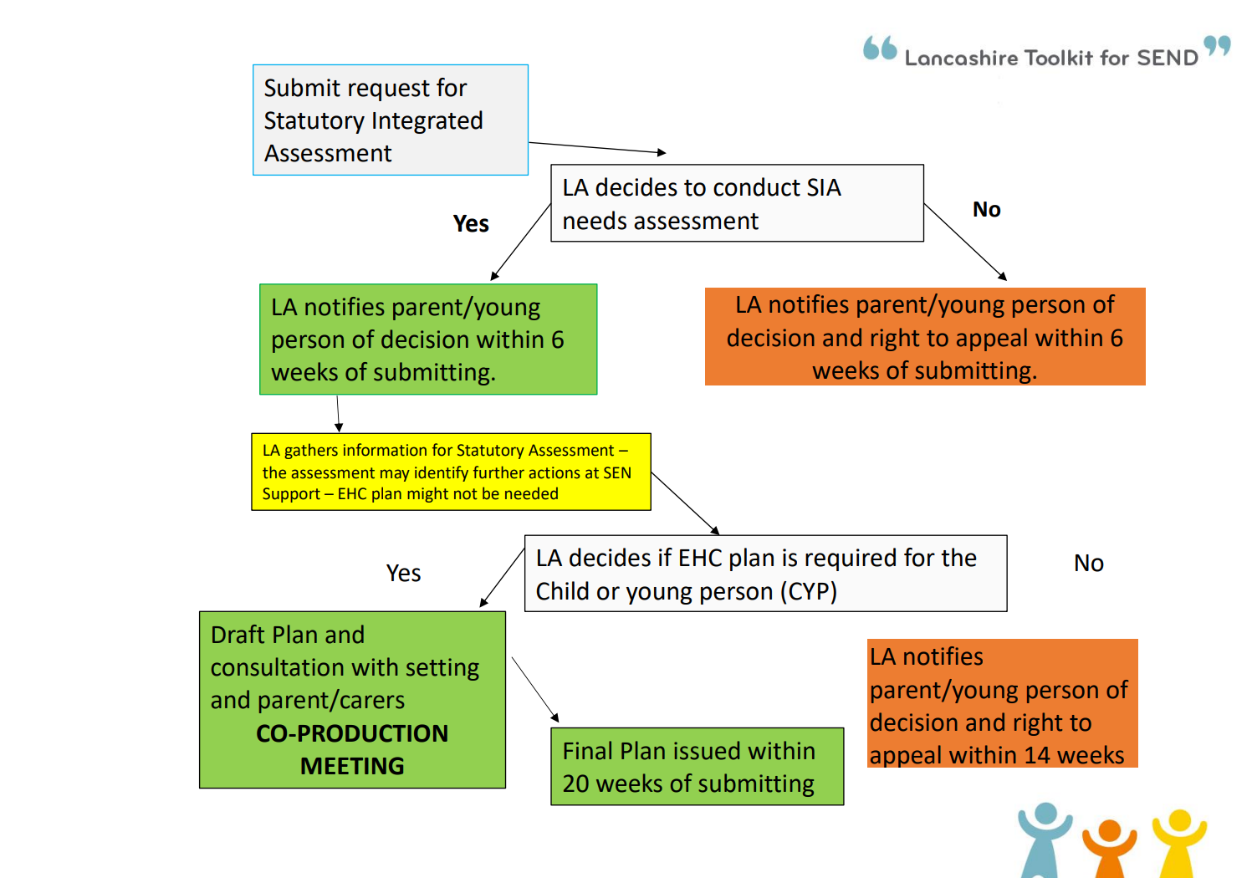

If at any stage the child makes considerable progress against their targets, then these will be discussed at a review meeting with all parties sharing information about the child. Following these discussions, it may be agreed that their level of need will be reduced or they may no longer need a one-page profile or targeted action plan. Parents will be involved in these discussions and will be notified of this progress and the actions taken. Like all children in our school, they will continue to be monitored to ensure their progression within their curriculum.

Arrangements for Statutory Reviews of EHCP Pupils

A statutory review takes place within one year of the date of the EHCP and every year after unless your child is under 5 then this will take place every 6 months until they turn 5. If school or the parents feel the EHCP may need amending prior to this, then we may call an emergency or early review meeting. We will invite parents and outside agencies to attend.
We place great importance on the transition of EHCP pupils into the EYFS and into Key Stage 2 and school will support parents in finding the most suitable placement for their child. At the children’s EHCP review in Year 2 representatives from the intended Key Stage 2 setting are invited to attend in order to ensure a smooth transition for the child.

3. Inclusion
Children with special educational needs are fully integrated into the life of the school and
represent the school on all occasions e.g. concerts, assemblies, visits and are expected to make very good progress. All pupil related policies are reviewed with regard to equal opportunities, human rights, disability discrimination etc. The Single Equality Scheme supports the inclusion of all pupils.

4. Evaluation of Provision
The effectiveness of provision for pupils with special educational needs will be evaluated by:
- The number of pupils making good progress, identified in pupil progress meetings.
- The number of pupils achieving well in the KS1 assessments.
- The progress made by individual pupils within targets identified in their profiles and action plans.

5. Special Educational Needs and Disability Act 2005
This Act introduces duties that protect disabled pupils from discrimination on the grounds of disability. A disabled pupil is defined as someone who ‘has a physical or mental impairment which has a substantial and long term adverse effect on their ability to carry out normal day to day activities’.

Rosegrove Infant School does not and will not treat disabled pupils less favourably in terms of admissions, provision of education or exclusions. The school will work with the LA to plan improvements to the physical environment, information and the curriculum. A copy of the Code of Practice with regard to this Act is kept in the Head Teacher’s office.

STAFF DEVELOPMENT AND PARTNERSHIP

1. Staff Development
The school is committed to the training of teaching and support staff in meeting a range of needs. Staff are encouraged to share expertise and to apply for external courses. The SENDCO provides training and feedback following any courses attended, arranges INSET sessions and gives advice and information where necessary. The Head Teachers ensure that teachers have PPA time to plan, which includes support for those with special educational needs. TA’s also have planning and preparation time as needed. Specialist teachers and outside agencies work closely with staff to share good practice.

2. Parents
The school recognises the importance of a partnership between home and school. Parents are kept informed of children’s progress and are encouraged to play an active part in their children’s learning and to support targets set. Parents with concerns about their child should discuss these first with the class teacher who will inform the SENDCO if necessary.

3. Links with Other Schools
The school works closely with local junior schools to ensure smooth transition and awareness of needs. Reception staff and the SENDCo visit pupils and key persons from feeder nurseries before the Summer holidays to ensure provision is put in place ready for their first day at school. Year 2 staff meet with colleagues from the Junior schools in the Summer Term before transfer and visits are made by Year 2 children to their new schools. Additional visits and resources are organised for pupils who may need more support during transition times.

4. Links with Outside Agencies
The SENDCO liaises with the Health Authority, Social Services, parent and voluntary organisations as well as educational support services. Records of involvement with outside agencies are kept.

5. Complaints Procedure
Parents who are dissatisfied with the school’s provision for special educational needs should in the first instance report this to the class teacher - if they remain dissatisfied, they should make an appointment to see the SENDCO/Head Teachers. Should this fail to resolve the problem, the matter can be reported to the school’s Governor for special educational needs, who may be contacted through the School Office. If parents are still not happy after using the school’s complaints procedure, the parents should contact the LA for advice, support and information.

REVIEW OF THE POLICY
This policy will be reviewed annually by Mrs D. Hudson (SENDCO) in order to ensure that it continues to reflect the objectives, needs and views of the school and its pupils and contains the necessary requirements regarding special educational needs, as outlined in the Special Needs Code of Practice 2015.

Signed | Signed
Head Teachers names:  Mrs L. Renshaw  Mrs C.Ashworth | Chair of Governors name:
Date: 30.09.26 | Proposed Review Date. Autumn term 2027

