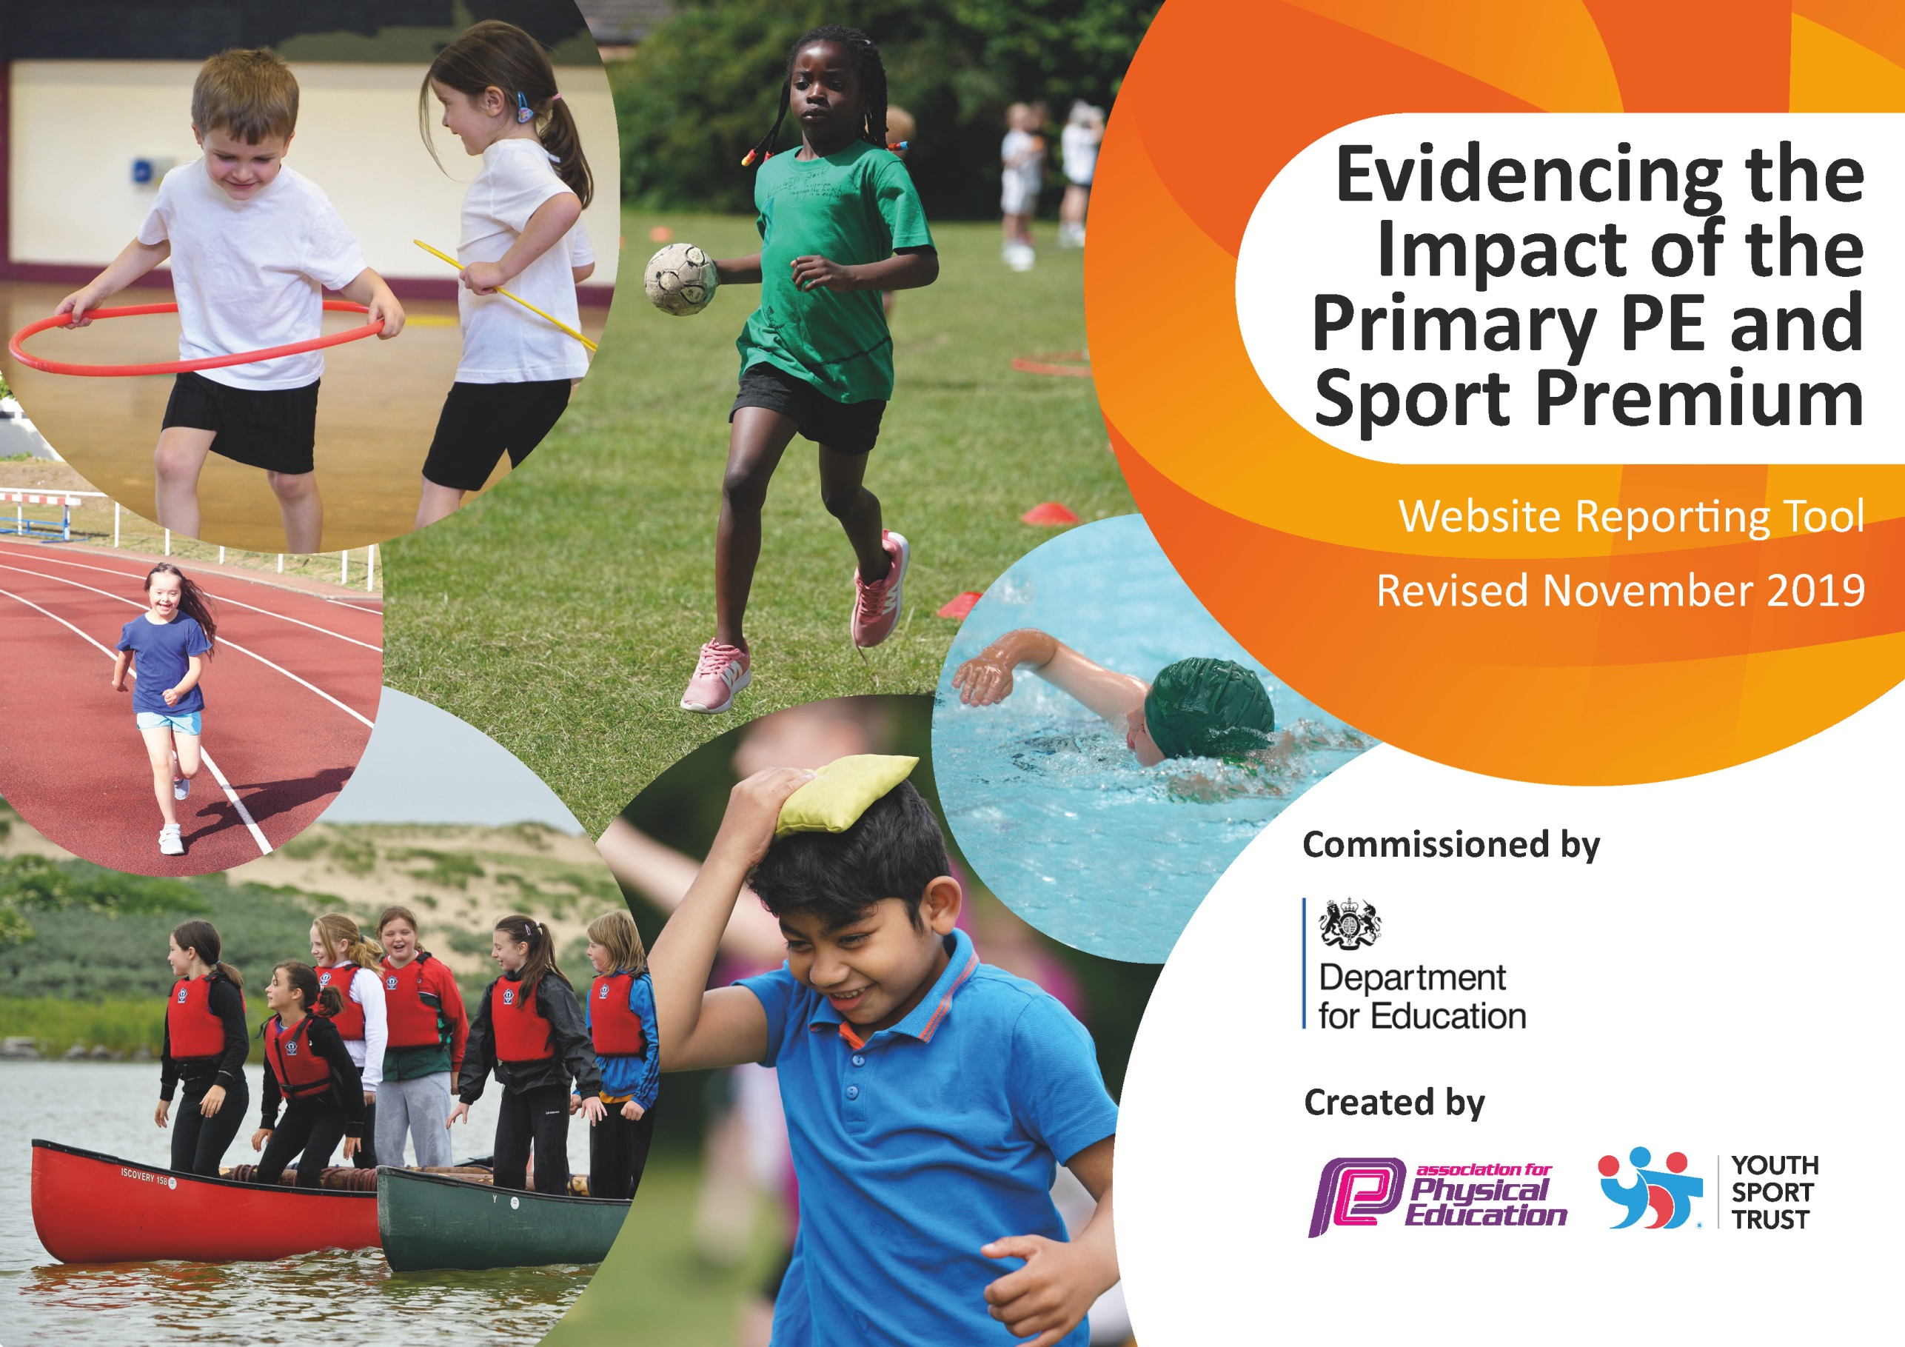
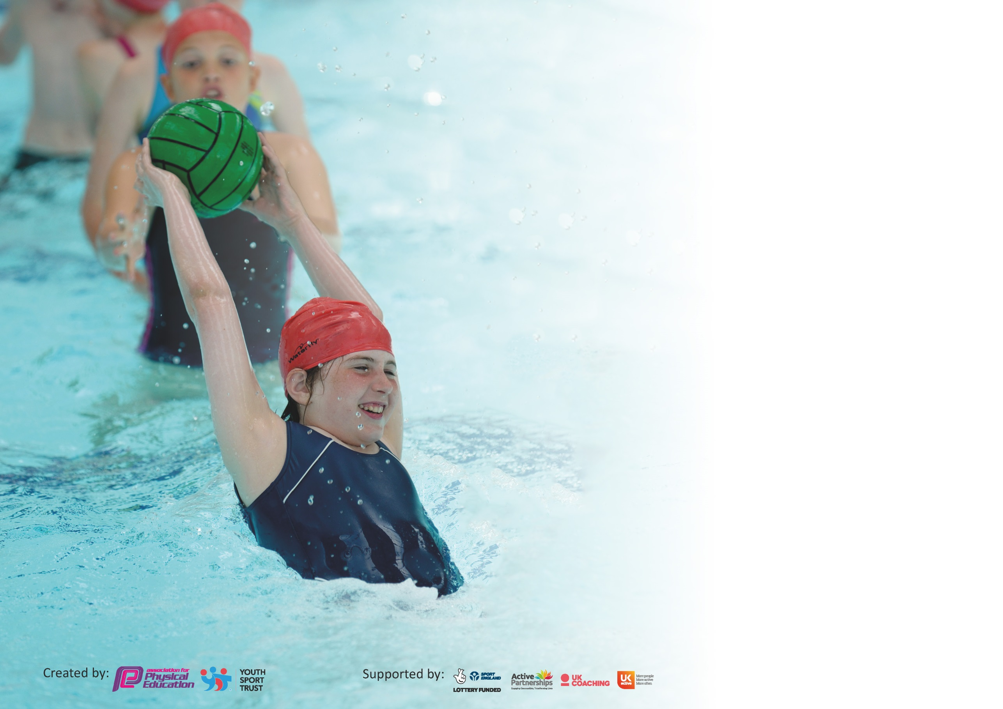

It is important that your grant is used effectively and based on school need. The Education Inspection Framework (Ofsted 2019 p64) makes clear there will be a focus on ‘whether leaders and those responsible for governors all understand their respective roles and perform these in a way that enhances the effectiveness of the school’.

Under the Quality of Education criteria (p41) inspectors consider the extent to which schools can articulate their curriculum (INTENT), construct their curriculum (IMPLEMENTATION) and demonstrate the outcomes which result (IMPACT).

To assist schools with common transferable language this template has been developed to utilise the same three headings which should make your plans easily transferable between working documents.

Schools must use the funding to make additional and sustainable improvements to the quality of Physical Education, School Sport and Physical Activity (PESSPA) they offer. This means that you should
use the Primary PE and Sport Premium to:

- Develop or add to the PESSPA activities that your school already offer
- Build capacity and capability within the school to ensure that improvements made now will benefit pupils joining the school in future years

Please visit gov.uk for the revised DfE guidance including the 5 key indicators across which schools should demonstrate an improvement. This document will help you to review your provision and to report your spend. DfE encourages schools to use this template as an effective way of meeting the reporting requirements of the Primary PE and Sport Premium.

We recommend you start by reflecting on the impact of current provision and reviewing the previous spend.

Schools are required to publish details of how they spend this funding as well as on the impact it has on pupils’ PE and sport participation and attainment by the end of the summer term or by 31st July 2020 at the latest.

We recommend regularly updating the table and publishing it on your website throughout the year. This evidences your ongoing self-evaluation of how you are using the funding to secure maximum, sustainable impact. Final copy must be posted on your website by the end of the academic year and no later than the 31st July 2020. To see an example of how to complete the table please click HERE.

Support for review and reflection - considering the 5 key indicators from DfE, what development needs are a priority for your setting and your pupils now and why? Use the space below to reflect on previous spend and key achievements and areas for development.

Key achievements to date until July 2019: | Areas for further improvement and baseline evidence of need:
-Funda have continued upskilling EYFS staff as well as preparing children for baseline assessments at the beginning of year 1. (Covid – until spring term)
-Continued to utilised SSP and utilised the full package of what is offered including CPD support and opportunities for physical activity (Covid – until spring term)
-New playground markings installed raising the level of physical activity at break times. Also created a safer environment for active play with designated zones for different activities.
-More children accessing outdoor learning area on a daily basis increasing further activity.
-Physical activity of 30 mins to be attained from increased structure of playground activities including enhanced equipment and resources, zoned areas and personal best cards.
-Teacher CPD continued to be enhanced.
-Healthy mind/mindfulness and promoting a healthy balanced lifestyle.
-School games values – integrated into physical activity sessions.
All achievements were up to spring term, due to COVID 19.

Meeting national curriculum requirements for swimming and water safety.
What percentage of your current Year 6 cohort swim competently, confidently and proficiently over a distance of at least 25 metres?  N.B. Even though your pupils may swim in another year please report on their attainment on leaving  primary school at the end of the summer term 2020. | %
What percentage of your current Year 6 cohort use a range of strokes effectively [for example, front crawl, backstroke and breaststroke]? | %
What percentage of your current Year 6 cohort perform safe self-rescue in different water-based situations? | %
Schools can choose to use the Primary PE and Sport Premium to provide additional provision for swimming but this must be for activity over and above the national curriculum requirements. Have you used it in this way? | Yes/No

Action Plan and Budget Tracking
Capture your intended annual spend against the 5 key indicators. Clarify the success criteria and evidence of impact that you intend to measure to evaluate for pupils today and for the future.

Academic Year: 2020/21 | Total fund allocated: £17000  Actual spend 17,410 but £3300 rolling over to next year. | Date Updated:17.06.21
Key indicator 1: The engagement of all pupils in regular physical activity – Chief Medical Officer guidelines recommend that primary school pupils undertake at least 30 minutes of physical activity a day in school |  |  |  | Percentage of total allocation:
 |  |  |  | 19%
Intent | Implementation |  | Impact
Your school focus should be clear what you want the pupils to know and be able to do and about  what they need to learn and to  consolidate through practice: | Make sure your actions to achieve are linked to your intentions: | Funding allocated: | Evidence of impact: what do pupils now know and what can they now do? What has changed?: | Sustainability and suggested next steps:
-Further extend the playground equipment with an increased focus on risk taking and ultimately leading to improved confidence in carrying out physical activity using the playground facilities.  -Continue to use the playground markings and zones to encourage structured physical activity on the playground.  -To enhance the facilities for the school for storing the playground equipment to increase the ease and facility of its use.  -To rapidly increase the amount of equipment available to be used to facilitate physical activity. | Ensure that all the trim trail equipment is being used effectively by all the children by class teachers leading class demonstrations on how to operate each piece of equipment.  Monitor the use of the different zoned off areas to ensure that the areas are serving their purpose and being used to enhance physical activity.  Order and implement more varied playground resources to be used in the equipment area and establish a routine for how they are to be stored and more importantly how they are to be used (link equipment use to the fundamental movement skills).  To ensure the children are using the musical playground wall in an effective way. | £3300  £2500 for climbing equipment/trim trail.  £500 for a range of new/varied equipment.  £300 for a new equipment trolley. | Covid 19  Playground enhancements have not been able to go ahead this year and as a result have been moved to the next academic year when the work is safe to be carried out.  Desired impact should be to create a playground which ultimately promotes structured physical activity throughout the day. | Monitor impact of different zones on the playground and constantly reinforce how they are to be used.  Ensure children are carrying out physical activities within the zones.  Provide children with varying equipment to use on the playground to allow them to  further promote their fundamental movement skills.  To ensure we provide children with more opportunities to carry out learning both on the playground and in the grove area to promote outdoor learning and opportunities for cross curricular learning.
Key indicator 2: The profile of PESSPA being raised across the school as a tool for whole school improvement |  |  |  | Percentage of total allocation:
 |  |  |  | 38%
Intent | Implementation |  | Impact
Your school focus should be clear what you want the pupils to know and be able to do and about  what they need to learn and to  consolidate through practice: | Make sure your actions to achieve are linked to your intentions: | Funding allocated: | Evidence of impact: what do pupils now know and what can they now do? What has changed?: | Sustainability and suggested next steps:
To provide opportunities for all children to practice and progress their fundamental movement skills and ultimately achieve age related expectations in Fundamental Movement Skills.  Provide the opportunity to receive expert guidance on how to carry out the fundamental movement skills.  To provide the children with opportunities to implement the skills they have learned in sporting situations and contexts. | Employ outside agency for 1 day per week to deliver, playtime and Lunchtime activities, 4 curriculum lessons and extracurricular clubs.  Funda educator and class teachers to work alongside each other to create engaging and progressive Funda lessons which results in the children becoming mature with each of the fundamental movement skills.  Covid 19  Lockdown has resulted in disruptions in the Funda scheme of work and subsequently children have missed being assessed on some the fundamental movement skills.  Year 1 have carried out the Funda scheme of work in the Autumn term and Year 2 have completed the scheme during the Summer term.  *Burnley SSP provided us with resources for our children so they had opportunities to carry out fundamental movement activities at home. | £6460 | Funda have delivered their own scheme in relation to the fundamental movement skills. They have delivered 6 afterschool clubs consisting of multi skills, cricket, dodgeball, netball, football and athletics and 10-15 children have attended.  Pupils have been taught on a small group basis (groups of 8) and have therefore had smaller group support to improve their accuracy and technique when carrying out the different fundamental movement skills they have been taught.  Document attached to show assessments of year 1 children in FMS taught and showing assessments of year 2 children at the end of the year.  Covid 19  Lockdown has resulted in some of the skills being missed within the Funda scheme of work some and assessments have been impacted.  *Document attached to show assessment of the 53 children in year 2 for the Fundamental movement skills (names removed). | Funda to continue delivering engaging PE lessons to enhance FMS skills.  School staff to continue to build up wealth of knowledge and ideas to implement in lessons after Funda have left.  Funda to continue to gain accurate assessments of children for developments and progress in PE.

Key indicator 3: Increased confidence, knowledge and skills of all staff in teaching PE and sport |  |  |  | Percentage of total allocation:
 |  |  |  | 0.2%
Intent | Implementation |  | Impact
Your school focus should be clear | Make sure your actions to | Funding | Evidence of impact: what do | Sustainability and suggested
what you want the pupils to know | achieve are linked to your | allocated: | pupils now know and what | next steps:
and be able to do and about | intentions: |  | can they now do? What has
what they need to learn and to |  |  | changed?:
consolidate through practice:
To ensure that all staff are aware of the curriculum map for what they need to be delivering each half term.  To sign up to the Lancashire PE membership to attain the new scheme and to learn about the new PE passport app resource and its use. | Perform regular monitoring by Subject Leader in the following areas:  -Analysis of Data  -Learning Walks and observations during Funda sessions, coaching sessions and Teacher led teaching.  -Peer Teaching  -Pupil Voice  -Assessments  To attend tutorial and gain advice on how to use both new scheme of work and new app for teaching and assessing.  To become competent and confident with using new PE teaching and assessment tool. | £450 | Covid 19  Bubble restrictions have led to inability to carry out learning walks and pupil interviews from other classes.  Lancashire scheme of work has been signed up for and tutorials will commence in September.  This new tool will enable children to be assessed easier and also so they can see how they need to improve with their FMS skills. | To implement the new Lancashire scheme of work across school.  To use the passport app to build up a repour of physical activity assessment and data.  To combine both the Funda scheme of work and the Lancashire work to ensure that the FMS are being applied within sporting contexts.
Key indicator 4: Broader experience of a range of sports and activities offered to all pupils |  |  |  | Percentage of total allocation:
 |  |  |  | %
Intent | Implementation |  | Impact
Your school focus should be clear | Make sure your actions to | Funding | Evidence of impact: what do | Sustainability and suggested
what you want the pupils to know | achieve are linked to your | allocated: | pupils now know and what | next steps:
and be able to do and about | intentions: |  | can they now do? What has
what they need to learn and to |  |  | changed?:
consolidate through practice:
To continue to provide the children with afterschool activity clubs which consist of varying and fresh content.  To use the outdoor areas to facilitate different physical activity sessions. Year 1 to continue to use the grove as an outdoor classroom and year 2 to use the zones on the playground. | Funda educator to carry out afterschool sessions every 3 or 4 weeks to expose as many children as possible to the afterschool clubs.  To continue to promote physical activity using all of the different areas outside including the grove area and the different zones. |  | 7 afterschool clubs have taken place this year with around 10-15 children attending across key stage 1 each time. Afterschool clubs include:  Multi skills, netball, cricket, football, dodgeball, athletics and gymnastics.  Covid 19 – Playground has had to be divided for areas for bubbles at playtime. PE has been carried out outdoors throughout. The zones haven’t been used as effectively as they could and this will be an intention for next year. | To continue with the Funda afterschool clubs and provide a wide repour of activities.  To completely implement the use of the zones on the playground to encourage physical activity during playtimes.

Key indicator 5: Increased participation in competitive sport |  |  |  | Percentage of total allocation:
 |  |  |  | %
Intent | Implementation |  | Impact
Your school focus should be clear | Make sure your actions to | Funding | Evidence of impact: what do | Sustainability and suggested
what you want the pupils to know | achieve are linked to your | allocated: | pupils now know and what | next steps:
and be able to do and about | intentions: |  | can they now do? What has
what they need to learn and to |  |  | changed?:
consolidate through practice:
Continue to offer weekly Level 1 competitive opportunities within the curriculum.  Ensure all children can access whole school events.  To continue the personal best card challenges on the playground for the children to carry out at playtimes and lunchtimes. | To carry out whole school competitive sports events including sports day and class PE competitive activities.  Continue to use competitive activities/challenges to playground to encourage use of new markings. |  | Whole school competitive sports day carried out on the playground in bubbles.  Classes were provided with activities to send out for children during lockdown and home learning.  Covid 19 – Competitions have not been as frequent this year and we have not been able to attend SSP competitions. Year 2 have completed the virtual competitions within PE lessons. | To attend all of the SSP competitions offered to us as a school.  To again use the personal best challenges on the playground to introduce competitive physical activity at playtimes.  To continue to promote competition during PE lessons both with Funda educator and with class teacher.
Key indicator 6: Improved Collaboration and growth of local networks |  |  |  | Percentage of total allocation:
 |  |  |  | 42%
Intent | Implementation |  | Impact
Your school focus should be clear | Make sure your actions to | Funding | Evidence of impact: what do | Sustainability and suggested
what you want the pupils to know | achieve are linked to your | allocated: | pupils now know and what | next steps:
and be able to do and about | intentions: |  | can they now do? What has
what they need to learn and to |  |  | changed?:
consolidate through practice:
All young people to be able to access opportunities that support their wellbeing  All young people to be able to access an events programme that will help them recognise improvement and achieve their personal best  Children to be able to access high quality PE | Buy into Burnley SSP – Autumn Term 19/20  Use associated buy in programmes such as competition and events programme to support children to take part in meaningful competition  Utilise SSP SSCO’s to continue to upskill school staff so they are competent | £1650 | The network has allowed us to share good practice and resources and the termly meetings keep us updated of COVID guidelines which aid and support our planning.  Using the resources provided by the SSP has helped to keep children active during lockdown | Continue to with SSP and to use their wealth of expertise and resources.
Support Children to recover mentally and physically from COVID-19:  Foster Social Connections  Improve skill development in sport  Provide Character and life skills  Improve physical fitness  Improve overall Wellbeing | Buy into Burnley SSP January 2021-July 2022  Access meaningful competitions in 2021-22  Use associated programmes available from the SSP to target provision to children who have been most negatively impacted by COVID 19.  Continue to access professional development and new resources that will help staff to competently deliver high quality PE. | £5550 | Children have been able to access resources during lockdown and have therefore been provided with opportunities to carry out FMS and activities. | Access competitions to allow children to gain a sense of competition.  Use SSP for support and guidance with new scheme of work and passport app.

Signed off by
Head Teacher: | Mrs Renshaw
Date: | 17.06.20
Subject Leader: | Mr Crossley
Date: | 17.06.21
Governor:
Date:

