Y1 Home Learning – Summer 2
Phonics-We are practising rapidly recalling phase 3 and phase 5 sounds and becoming more accurate when using them to read and write words within sentences this term.
Log on to phonics play and choose the phase 5 games https://new.phonicsplay.co.uk/
Play the phonics games on ictgames.com https://www.ictgames.com/mobilePage/literacy.html
Play the online phonics games on Twinkl
Phonics Galaxy game https://www.twinkl.co.uk/resource/twinkl-phonics-galaxy-game-tg-ga-193
Name the Alien https://www.twinkl.co.uk/resource/T-GO-10-name-an-alien-phase-5-phonics
Phonics gameshow https://www.twinkl.co.uk/resource/tg-ga-159-level-5-phonics-game-show
-Keep playing 15 minute flashcard games with the phase 5 sounds, here are some ideas but please share any you come up with that work well at home!
-make your own bingo game with the sounds
-beat the clock and challenge yourself to read or write so many words containing the phase 5 sounds in a minute
-write out words containing the sounds and hide them around your house or garden to find
-play musical phonics (like musical statues but when the music stops you say the sound on the flashcard)
-race to collect word cards then sort into bowls/containers according to the sound in the word
-rainbow write in different colours words containing the same sound
-write words and add sound buttons for each sound e.g. 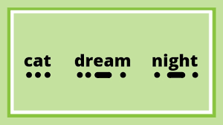
-write a word then change one or two letters each time to make a new word with the same sound you are practising e.g. beach, reach, teach, team, dream, steam, steal etc
-choose two sounds write them and stick them on opposite sides of the room then write lots of words on cards containing
each sound. Pick a card, read the word and run to the side of the room displaying the correct sound in the word. (This is a good one for practising two ways of spelling one sound e.g. ee in feet and ea in reach.)
-If you find you are struggling to learn or remember a particular sound, visit the daily letters and sounds lessons for reception and Year 1. The lessons are numbered and the sound each lesson covers is on the opening screen of each lesson. https://www.youtube.com/channel/UCP_FbjYUP_UtldV2K_-niWw
-Have a go at some of these phonic activity mats, if you don’t have a printer, just write them in your book.
https://www.twinkl.co.uk/resource/t-l-526449-phonics-activity-mat-1-resource-pack-english
https://www.twinkl.co.uk/resource/t-l-526517-phonics-activity-mat-resource-pack-2
Practise reading and spelling the following words.
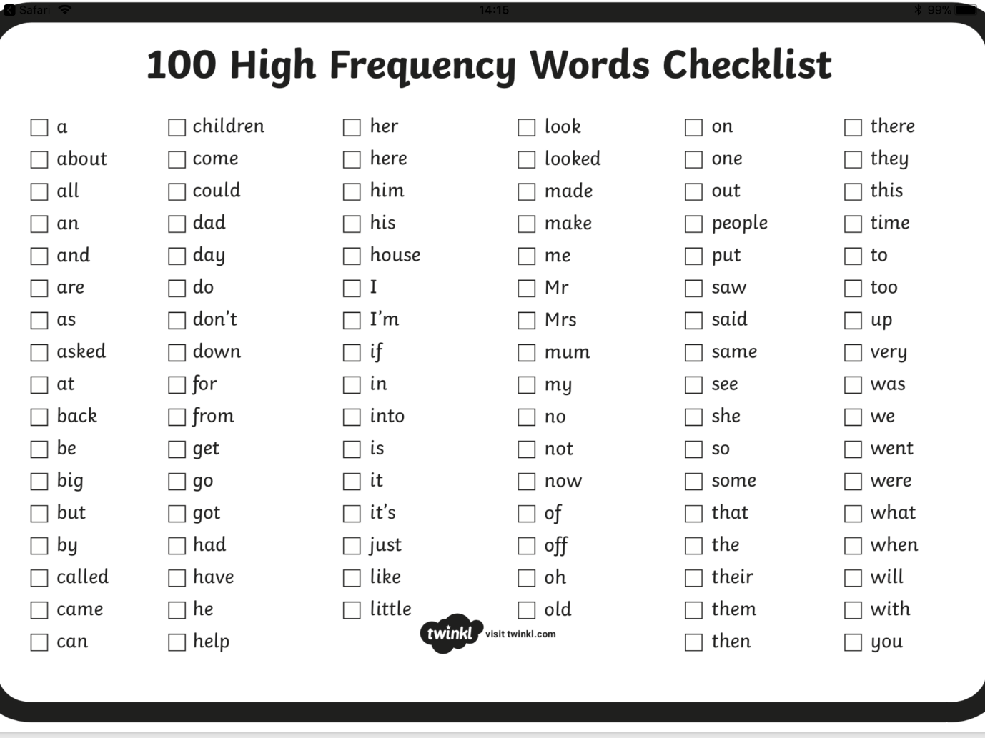
Have a go at some of these mats to help you, if you don’t have a printer you can write them in your book.
https://www.twinkl.co.uk/resource/100-high-frequency-words-bumper-activity-pack-t-l-9357

Science – This half term we are learning about minibeasts and their habitats.
-Go on a minibeast hunt, draw
and write down how many
you find. Make a pictogram
to show how many of each minibeast you find.
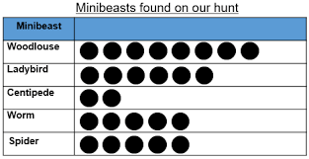
Where a minibeast lives is called it’s habitat. What is in the habitat that makes it a good place to live? Make your own minibeast habitat. What do you think your minibeast would like in it’s habitat to help it stay safe, keep healthy and survive? Draw and label your minibeast habitat.
Remember to handle minibeasts carefully, always put them back where you found them and wash your hands after.
-Use these sheets to label the body parts of a minibeast or draw and label your own. https://www.twinkl.co.uk/resource/t-t-982-parts-of-the-insect-activity
-Choose a minibeast, find out lots of facts about it and make a fact file about your minibeast. You could find out about lots of different minibeasts and make your own minibeast fact file book full of pictures and interesting facts!
-Find different ways to sort minibeasts. Use these cards or draw and make your own to sort the minibeasts into groups e.g. can fly/can’t fly, number of legs.https://www.twinkl.co.uk/resource/t-t-917-minibeast-identification-worksheet

Geography - This half term we are learning about bird’s eye view and how to make our own maps.
-Look at objects from above and talk about how they look different from the side. This is called a bird’s eye view or aerial view. Draw what they look like from above.
-Put some toys in a pattern on the floor to make a map of them and take a photo or draw a picture of them from above. Move the toys around then try to recreate the same map using the photo or picture to help you.
-Look at maps with a grown up, talk about the features you can see on a map such as roads, rivers, landmarks etc. Can you work out what the symbols are on the map?
-Watch the lesson presentation about maps and complete the activities. https://www.twinkl.co.uk/resource/tp-g-008-planit-geography-year-1-our-school-lesson-6-marvellous-map-symbols-lesson-pack
-When you go for a walk, look at the buildings, landmarks and objects you pass along the way. Draw a map of your route and include pictures and symbols of the things and places you see on your walk.

Art – This half term we are learning about observational drawing skills
-we have made our own Matisse snail pictures in school. What other artwork can you find by Matisse? Can you make your own artwork in the same style?
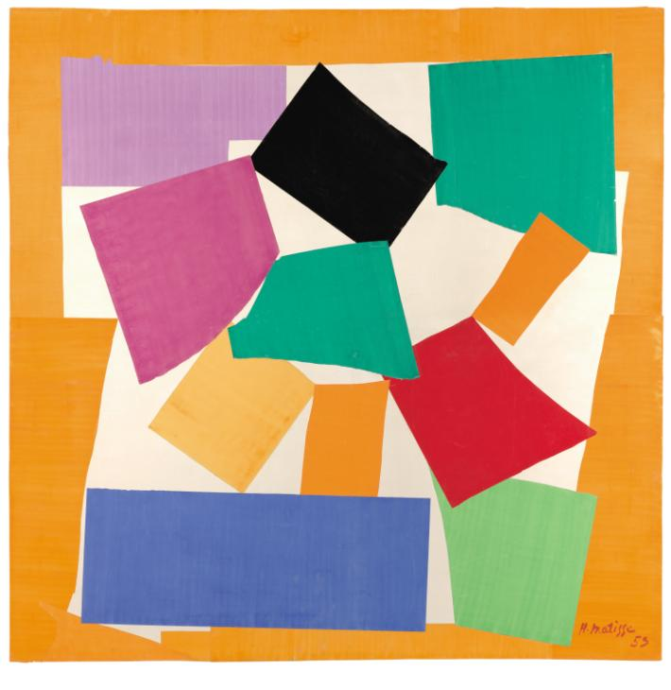
-Find pictures of minibeasts or look for some in your garden. Look carefully at the detail, pattern and shapes and draw them. You could colour them in or try shading by holding the pencil on its side and pressing harder or lightly to get different shades. Don’t forget to send us some photos of your work!
-Use the butterfly outline here https://www.template.net/design-templates/animal-templates/butterfly-shape-templates/ or draw your own outline. Draw lots of lines from one edge of the wing to the other, overlapping until you have a pattern of lots of small shapes. Colour or shade each shape to create your own colourful/shaded butterfly.
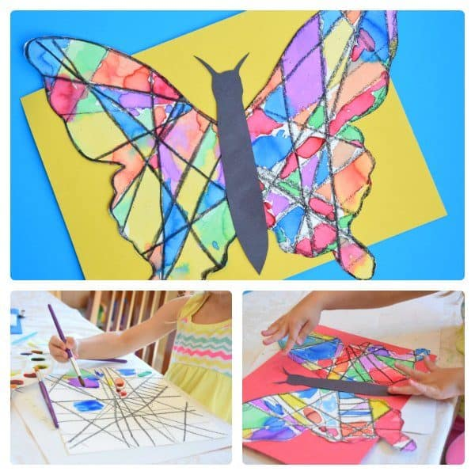

DT- This half term we are learning to plan, prepare make and eat healthy food.
-Ask an adult to help you practise safely preparing different fruit and vegetables e.g. cut, peel, grate chop, scoop and slice. Take care and listen carefully to the adult as they show you how to use the equipment safely.
-Plan your own healthy pizza. What healthy toppings would you put on? Draw your pizza with its healthy toppings. You could make your own pizza by adding your own toppings to a pizza or even making your own base! (you could try using muffins or a baguette for the base instead!) Don’t forget, to make the toppings as healthy as you can! Evaluate your pizza; what worked, what didn’t work and why, how would you improve it next time?
RE – This half term we are learning about Hindu festivals.
-Research the Hindu festivals of Holi and Divali

Read the fact file about the Hindu festival of Holi. https://www.twinkl.co.uk/resource/t-l-54698-ks1-holi-differentiated-fact-file.

-Make a poster to show what happens during Holi. Draw and write sentences about the festival.

-Read Dipal’s Divali https://www.twinkl.co.uk/resource/dipals-diwali-ebook-t-or-2028 and talk about the ways Dipal celebrates.

-Have a go at some of the Divali activities here. https://www.twinkl.co.uk/resource/t-t-7092-diwali-lesson-plan-ideas-ks1

-What festivals do you celebrate? Draw and write about how and why you celebrate them.

PSHE – This half term we are learning about personal safety and coping with worries and anxieties, especially during the national pandemic.
-Follow the link to find lots of activities to help with worries https://www.twinkl.co.uk/resource/anxiety-and-stress-activity-pack-t2-p-628
It is often hard to cope with something that makes you feel scared, worried, upset or confused. Most young people will feel like this and they will sometimes need help to feel better. There are things you can do to help you deal with these difficult emotions e.g. try breathing exercises, think about something that makes you happy. Look at the resilience flashcards here https://www.twinkl.co.uk/resource/resilience-flashcards-t2-p-534 Try some of the ideas and see if they work for you. If you find an idea that works, then please keep trying this. You may need to look at the flashcard over and over again until you remember what to do. Make a book of resilience ideas that work for and add any new ones as you discover them.
-Talk to a grown up about how to keep safe in Summer. Make a Summer safety poster helping people keep safe in the hot weather.
-Make your own set of family online safety rules.
-Read the free book Corona Virus- a book for children found here https://nosycrow.com/tag/coronavirus/ .Talk to an adult about any questions or worries you may have.

Music – This half term we are learning about rhythm and pulse and how we can use our bodies to make rhythms.
-Make your own clapping rhythms up and see if someone can copy them. Can you add different body part sounds to make it trickier?
-Ask your family if they know any clapping playground games. Look here to find some ideas, https://www.realplaycoalition.com/activities-for-kids/hand-clapping-games/ or ask an adult to help you find some on the internet, there are lots on YouTube. Learn and perform them with a partner. Can you change the words or make your own up?

Computing-This half term we are learning about algorithms and making our own simple computer games.

Use the link: https://www.discoveryeducation.co.uk/resources/primary/espresso/
and log in using the username sent via your learning email from your class teacher.
Select coding then underneath block coding click on Learn Select level 1 then follow the videos and lessons to create your own computer games.
Use the glossary to help you understand the coding terms used.
Use the create button to learn how to create your own App.

