

Rosegrove

Out of School Club

September 2022

## Thank you for choosing to use our breakfast and/or after school club.

**Information:**

**Fees**:

Breakfast sessions: £6.00

After School Sessions £12.00

Full Week (with 12.5% Discount) £78.75

**Times**:

**Breakfast Sessions:**

We open at 7.45 a.m.

**After School Sessions:**

Last pick – up is at 5.30 p.m.

*School will be closed after this time.*

Repeated lateness may incur additional fees.

Fees should be paid at least on week in advance to the school office where possible.

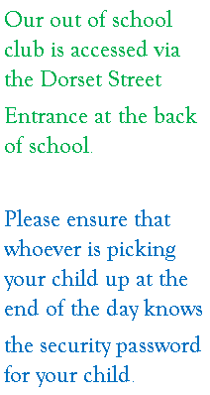

**Staff**:

Breakfast Club:

Supervisor – Mrs Barlow

Assistant – Mrs Burrows

After School Club:

Supervisor - Miss Stobbs

Assistant – Miss Blackburn